1.A) Feeds, Collateral Cash

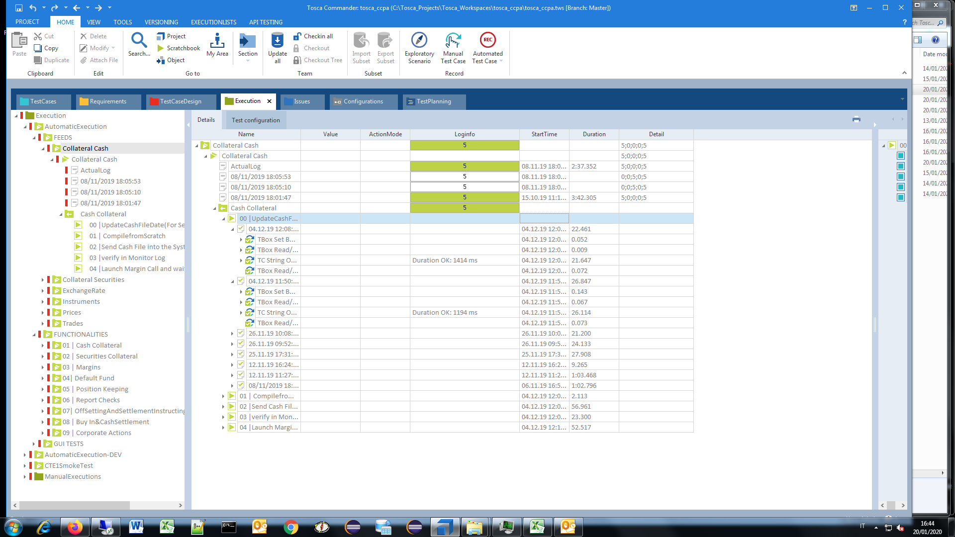

1.B) Collateral Cash, Cash Collateral, Send Cash File into the System

- Target Directory ITE2 Not available.

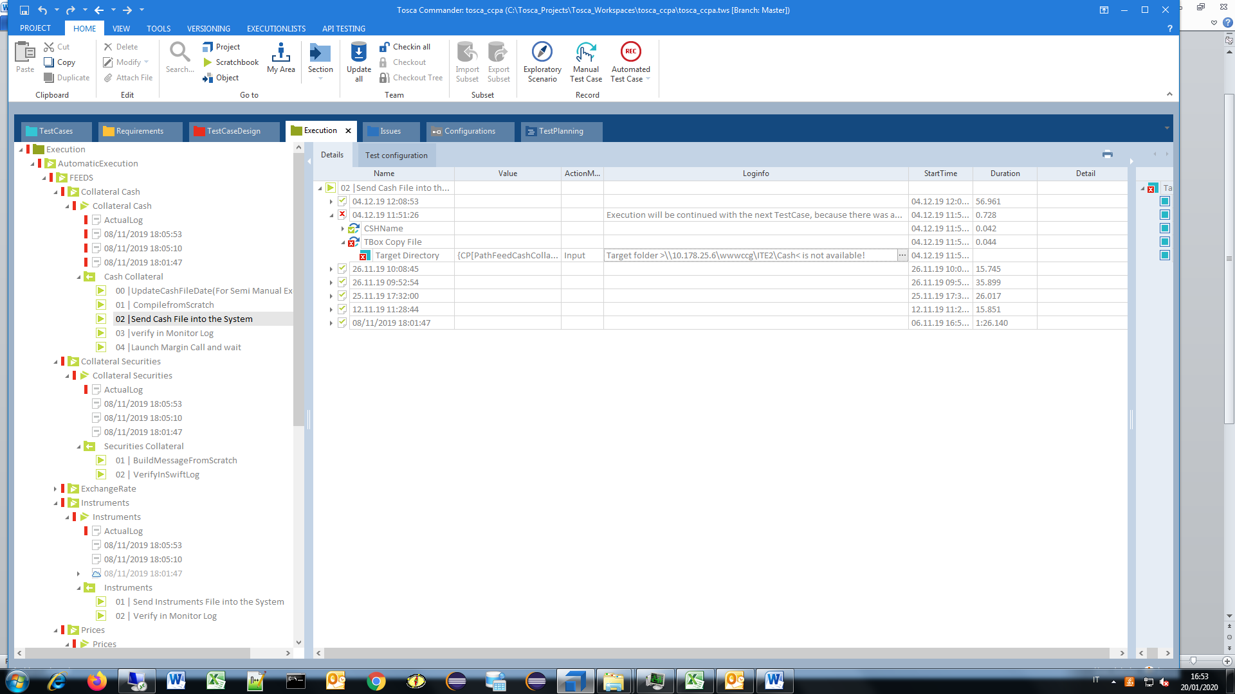

1.C) Collateral Cash, Cash Collateral, Verification fields - Different values (1)

Verification has .

Expected value == "CASH000"

Actual value: "CHK-03"

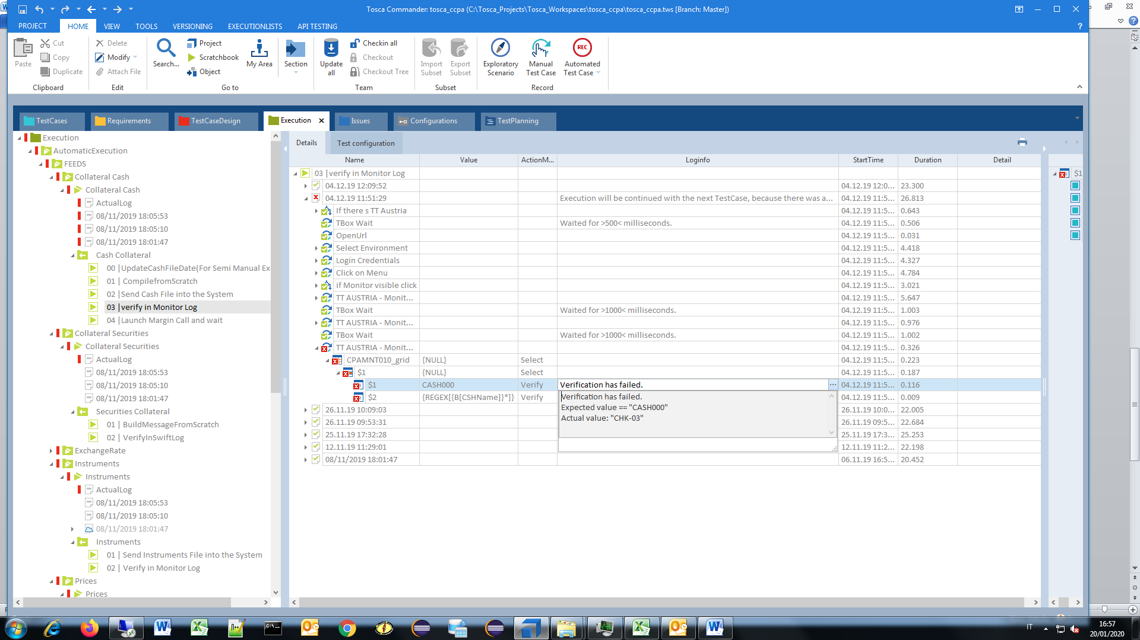

1.D) Collateral Cash, Cash Collateral, Verification fields -Different values (2)

Verification has .

Expression: "== CSH191204_115127.txt*"

Actual value: "WARNING! CHK-03 Check of Cash Collateral /Security Collateral"

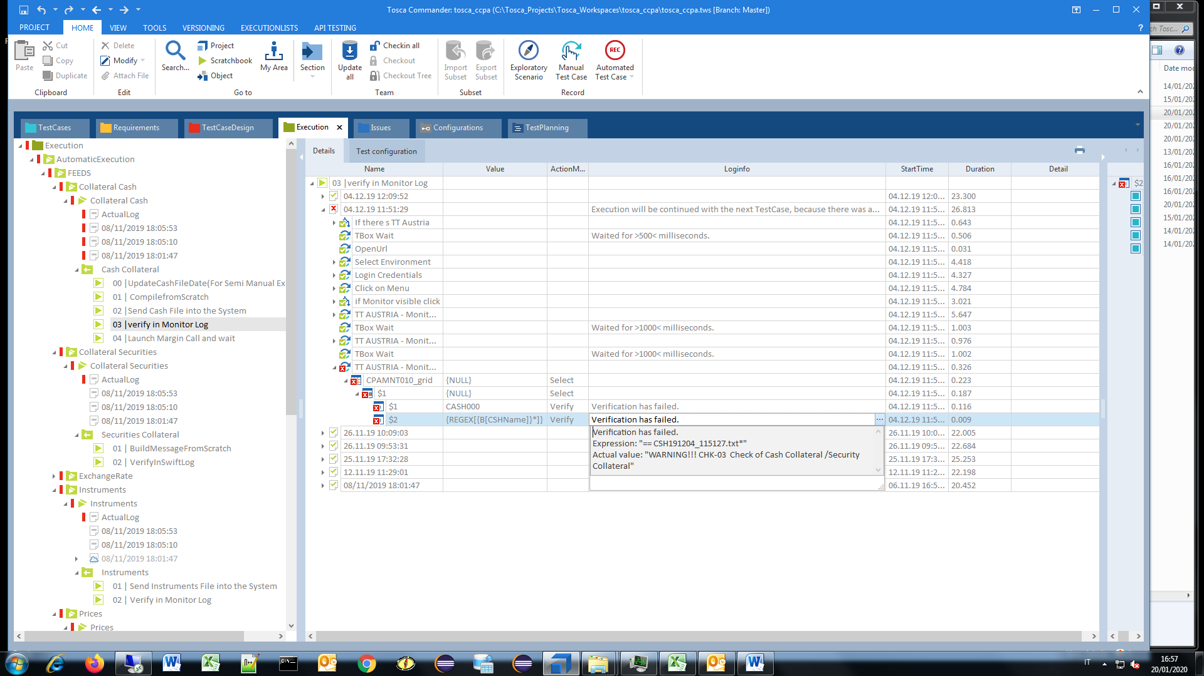

2.A) Collateral Securities, BuildMessageFromScratch, TBox Wait

- System Threading ...

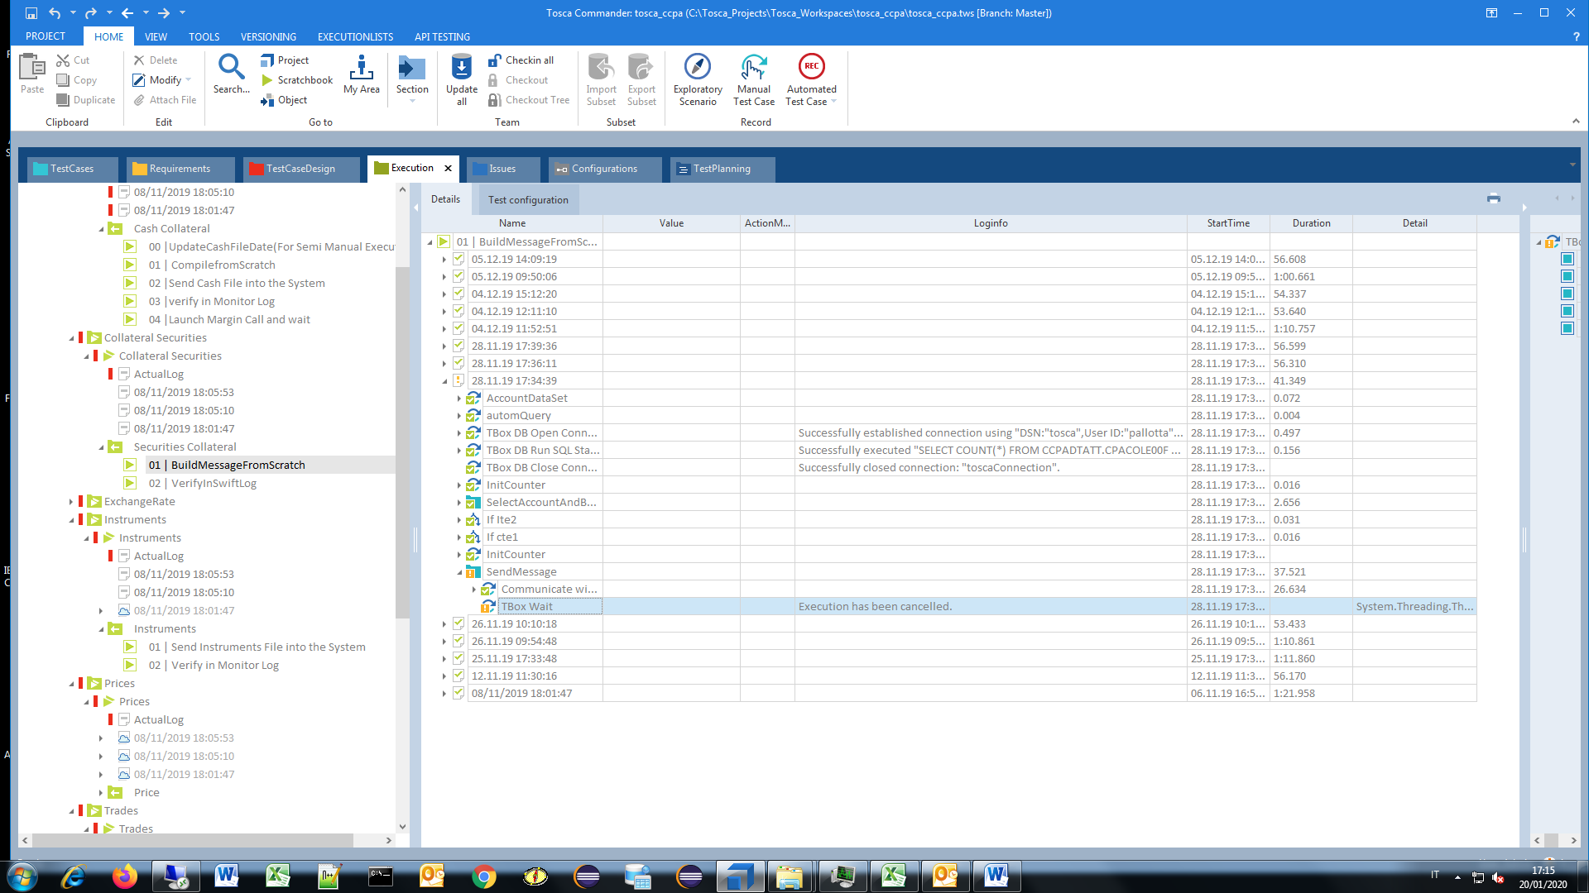

2.B) Collateral Securities, Securities Collateral, VerifyInSwiftLog

- CPASCHKW10_grid,

Verification has .

Expected value == "P"

Actual value: "R"

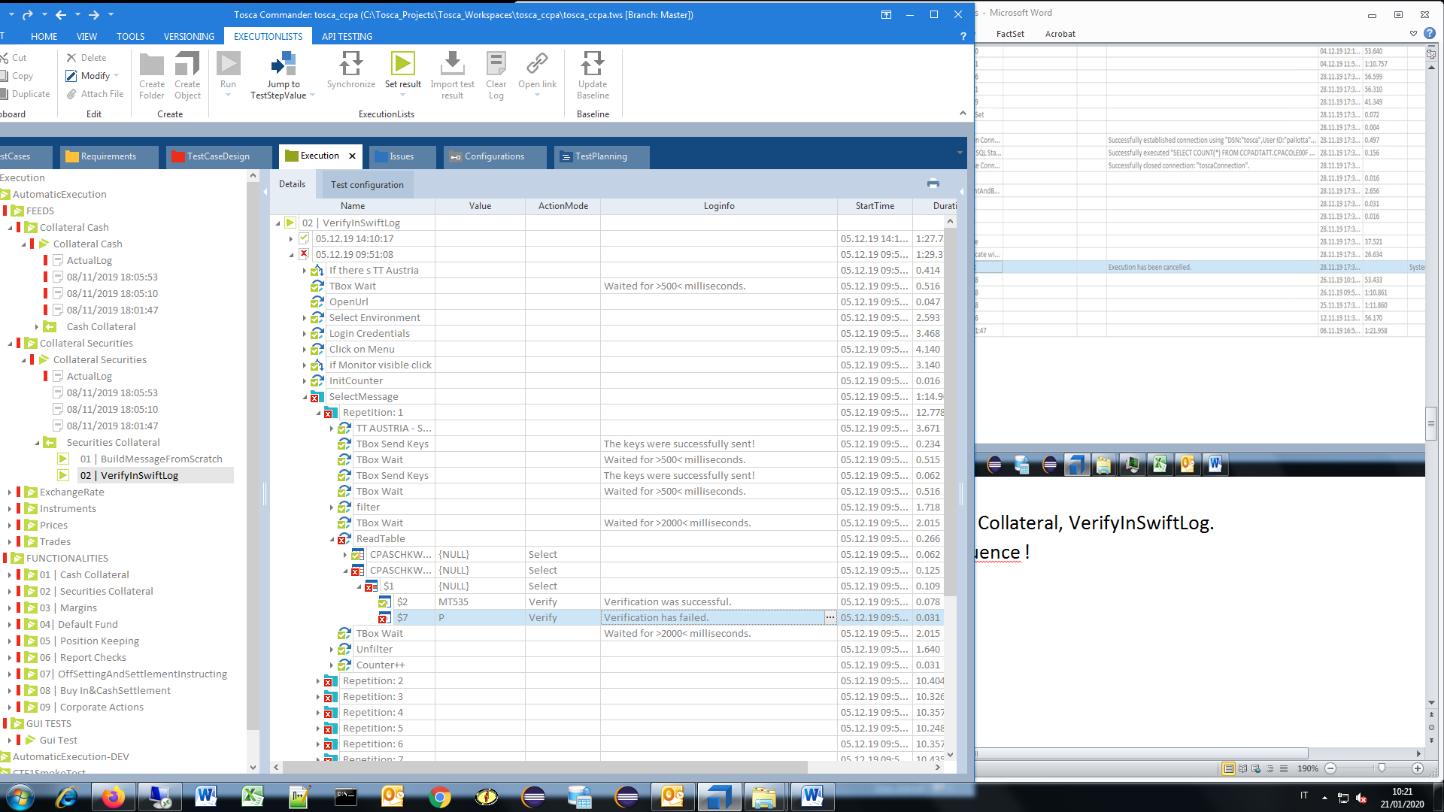

3.A) Exchange Rate, UpdateExchangeRateFile

ERROR [42S02] [Microsoft][ODBC Text Driver] The Microsoft Jet database engine could not find the object 'fx_refkurs.csv'. Make sure the object exists and that you spell its name and ERROR [HY000] [Microsoft][ODBC Text Driver] Text file specification field separator matches decimal separator or text delimiter.

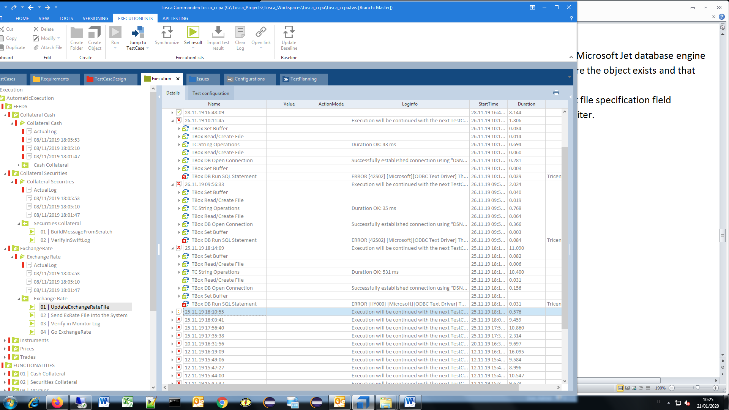

3.B) Exchange Rate, UpdateExchangeRateFile

- SELECT * FROM [fx_refkurs.csv]

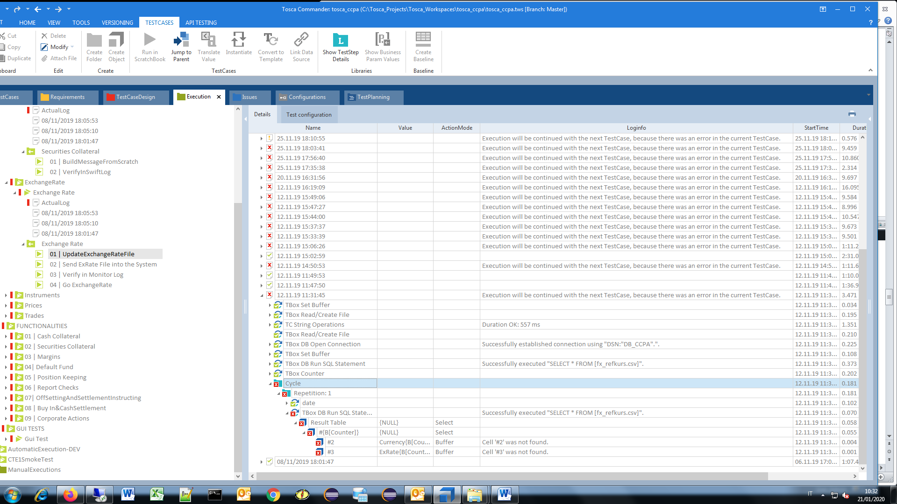

3.C) Exchange Rate, Update Exchange Rate File

ERROR [42S02] [Microsoft][ODBC Text Driver] The Microsoft Jet database engine could not find the object 'fx_refkurs.csv'. Make sure the object exists and that you spell its name and the path name correctly.

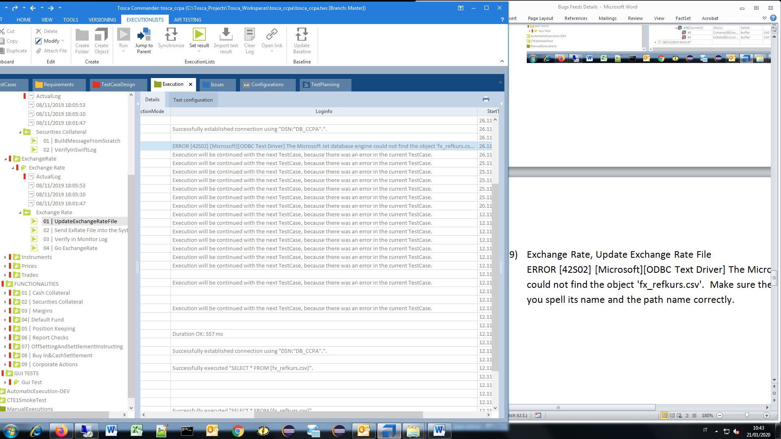

3.D) Exchange Rate, Update Exchange Rate File

- ciclo

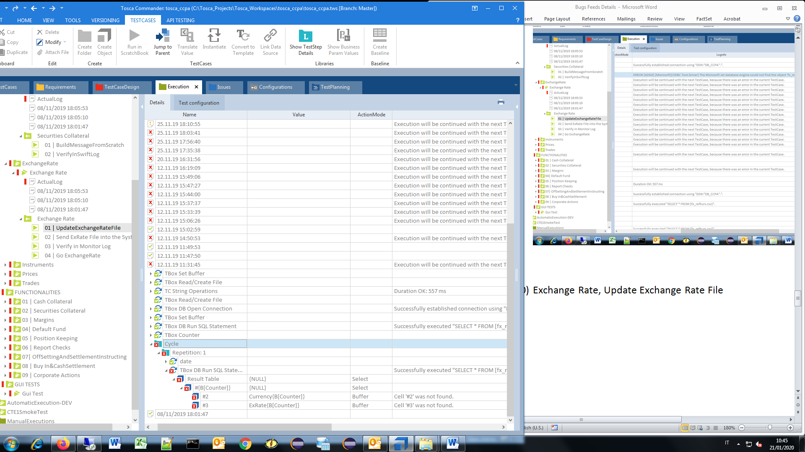

3.E) Exchange Rate, Send ExRate File into System

-Target folder >\\10.178.25.6\wwwccg\ITE2\ExRate< is not available!

- Execution will be continued with the next TestCase, because there was an error in the current TestCase.

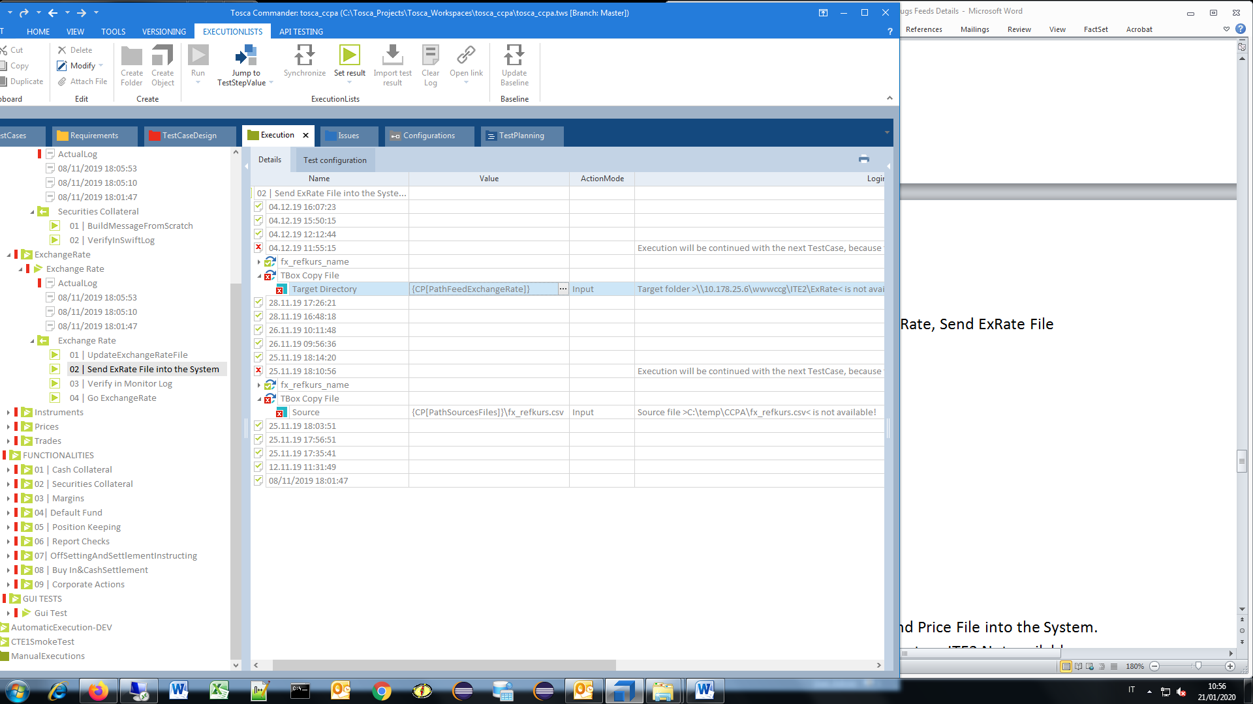

3.F) Exchange Rate, Verify in Monitor Log, TT AUSTRIA – Monitor Log, verification

- CPAMNT010_grid

Verification has .

Expected value == "XRAT000"

Actual value: "INST000"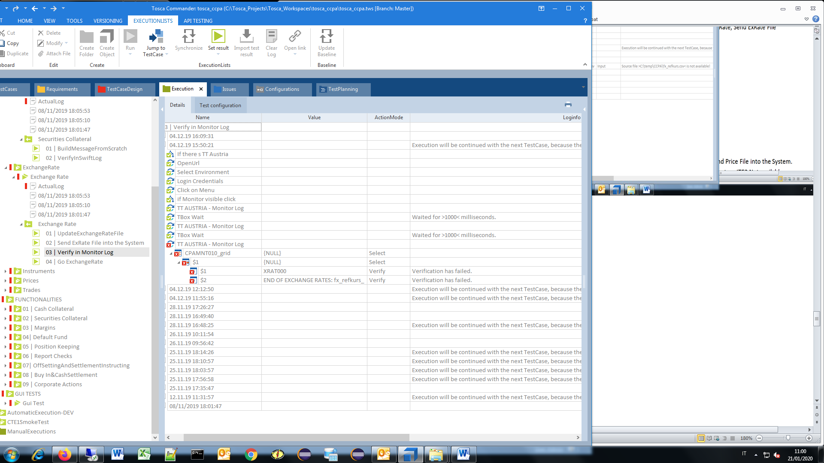

3.G) Exchange Rate, Verify in Monitor Log, TT AUSTRIA – Monitor Log, verification , END OF EXCHANGE RATES: fx_refkurs_

Actual Exchange Rate, Verify in Monitor Log, TT AUSTRIA – Monitor Log,

* Login Credentials - More than one matching tab was found.

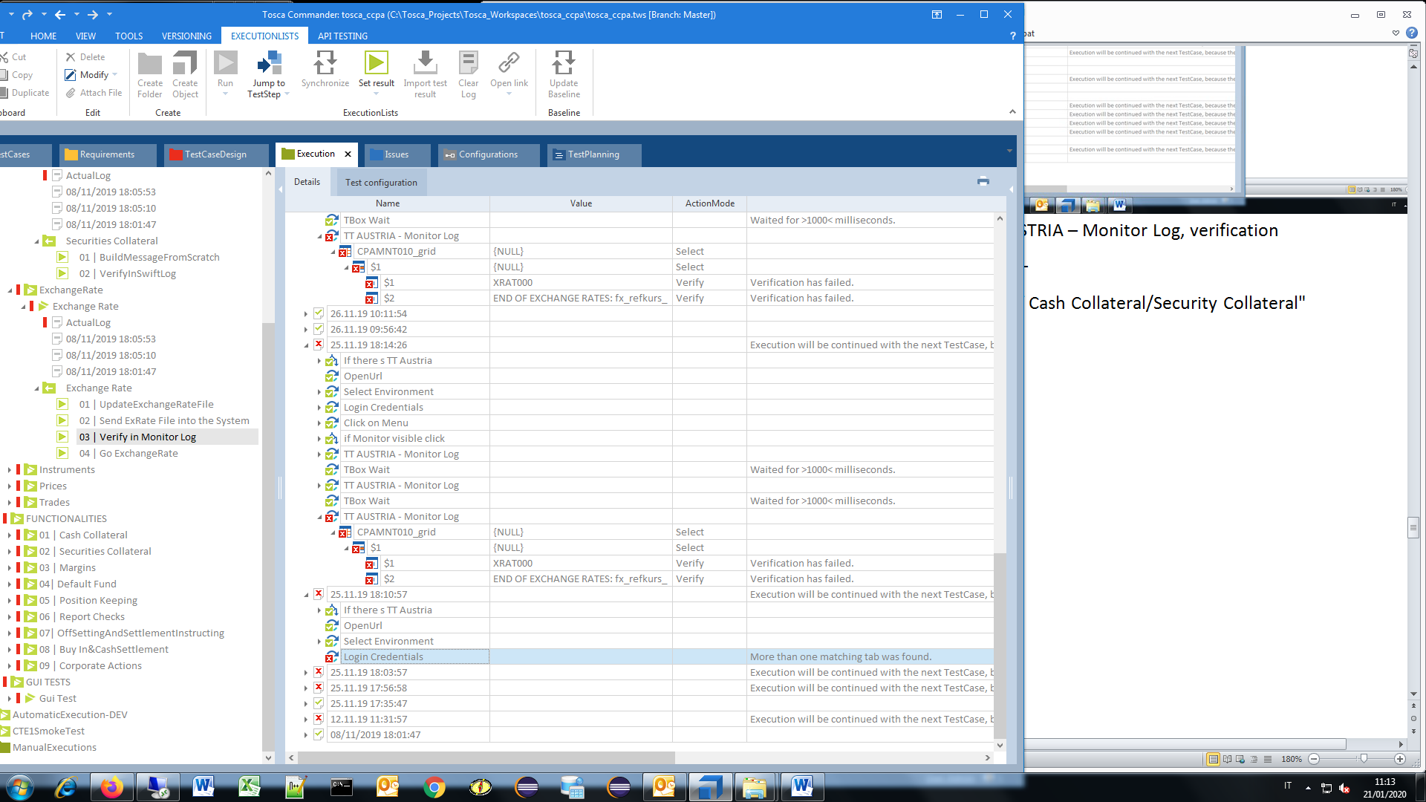

3.H) Exchange Rate, Verify in Monitor Log, TT AUSTRIA – Monitor Log, verification

Expected value == "END OF EXCHANGE RATES: fx_refkurs_"

Actual value: "END OF INSTRUMENTS FILE: instrumentvie20191128.CSV"

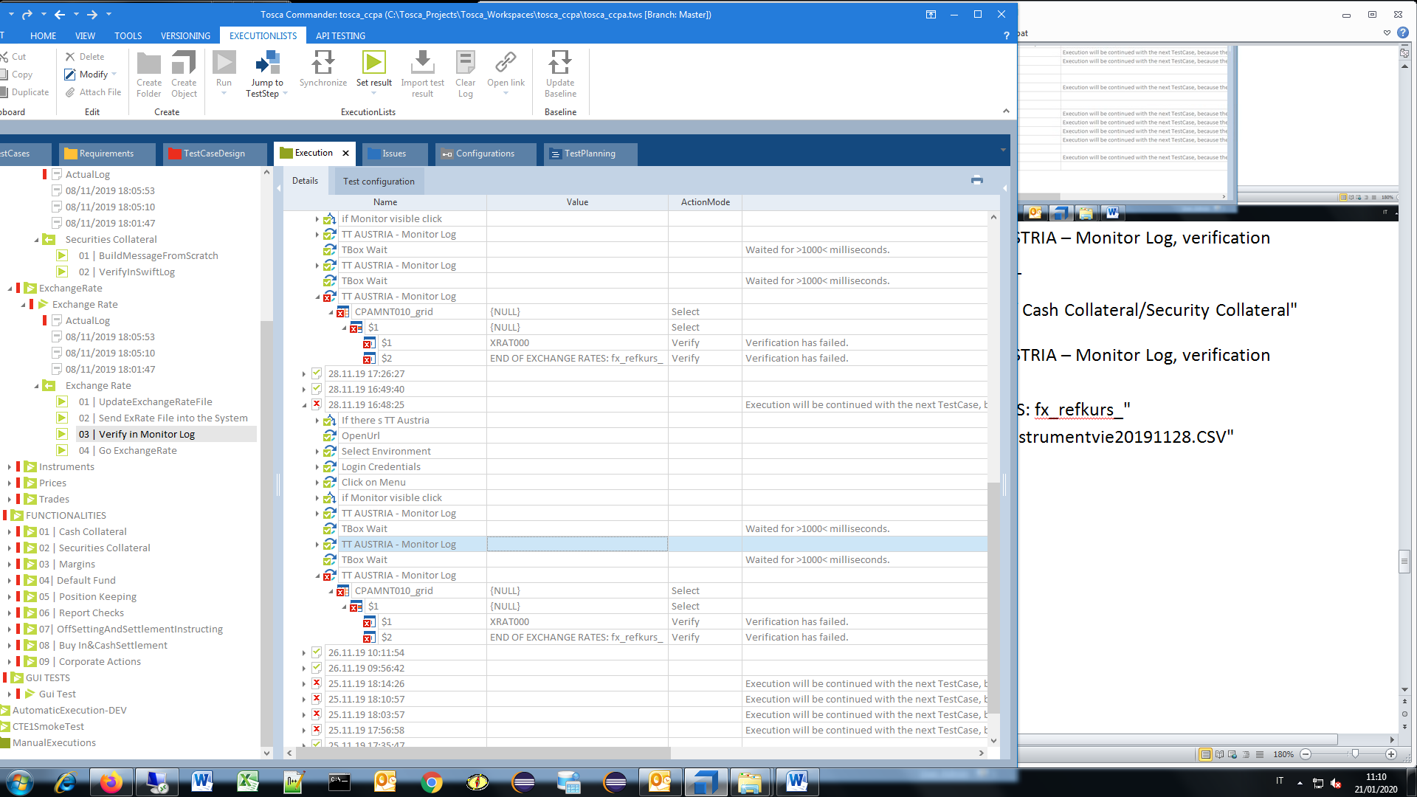

3.I) Exchange Rate, Verify in Monitor Log, TT AUSTRIA – Monitor Log, verification

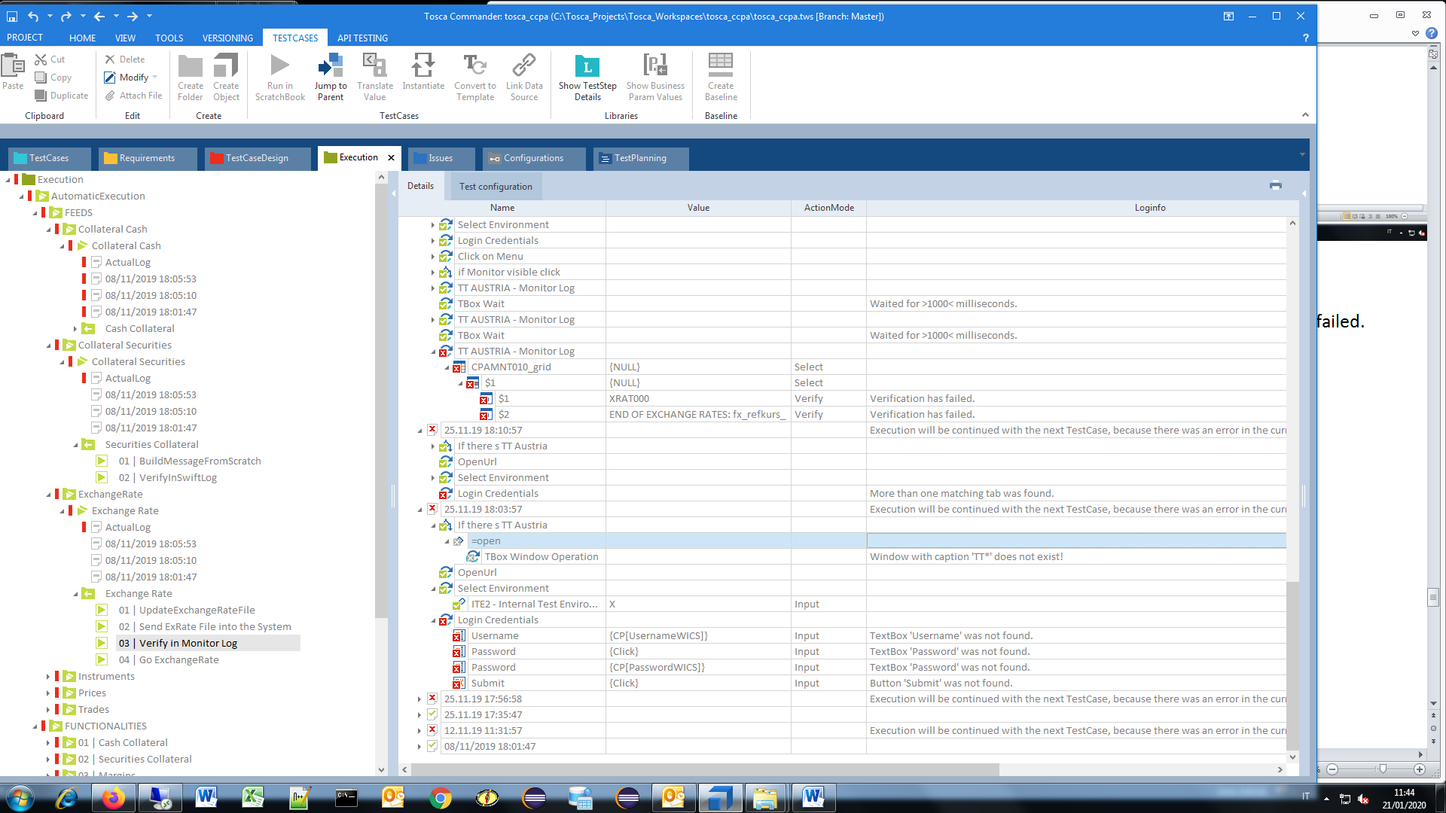

- Username, password, submit button NOT FOUND -

3.L) Exchange Rate, Go ExchangeRate

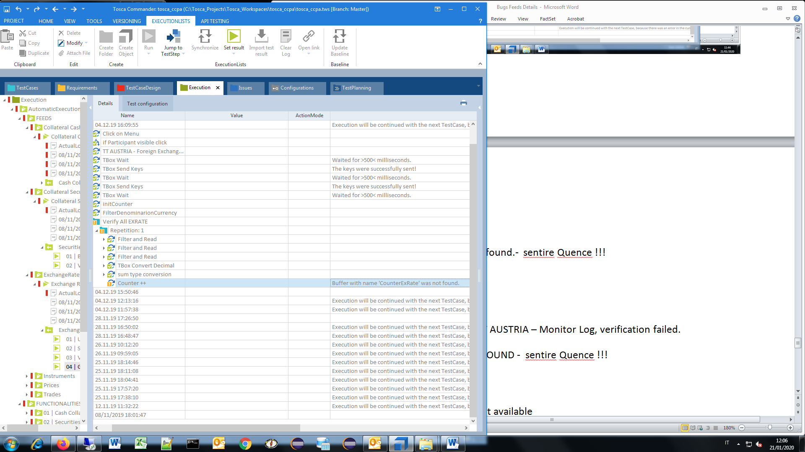

- Buffer with name 'CounterExRate' was not found.

3.M) Exchange Rate, Go ExchangeRate, Execution has been cancelled

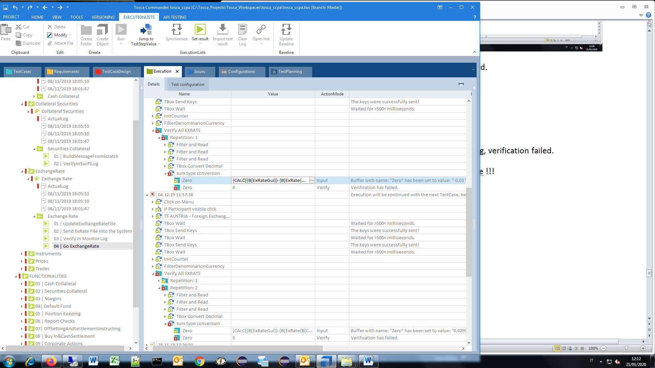

-{CALC[{B[ExRateGui]}-{B[ExRate{B[Counter]}]}]}

Buffer with name: "Zero" has been set to value: "-0,03 "

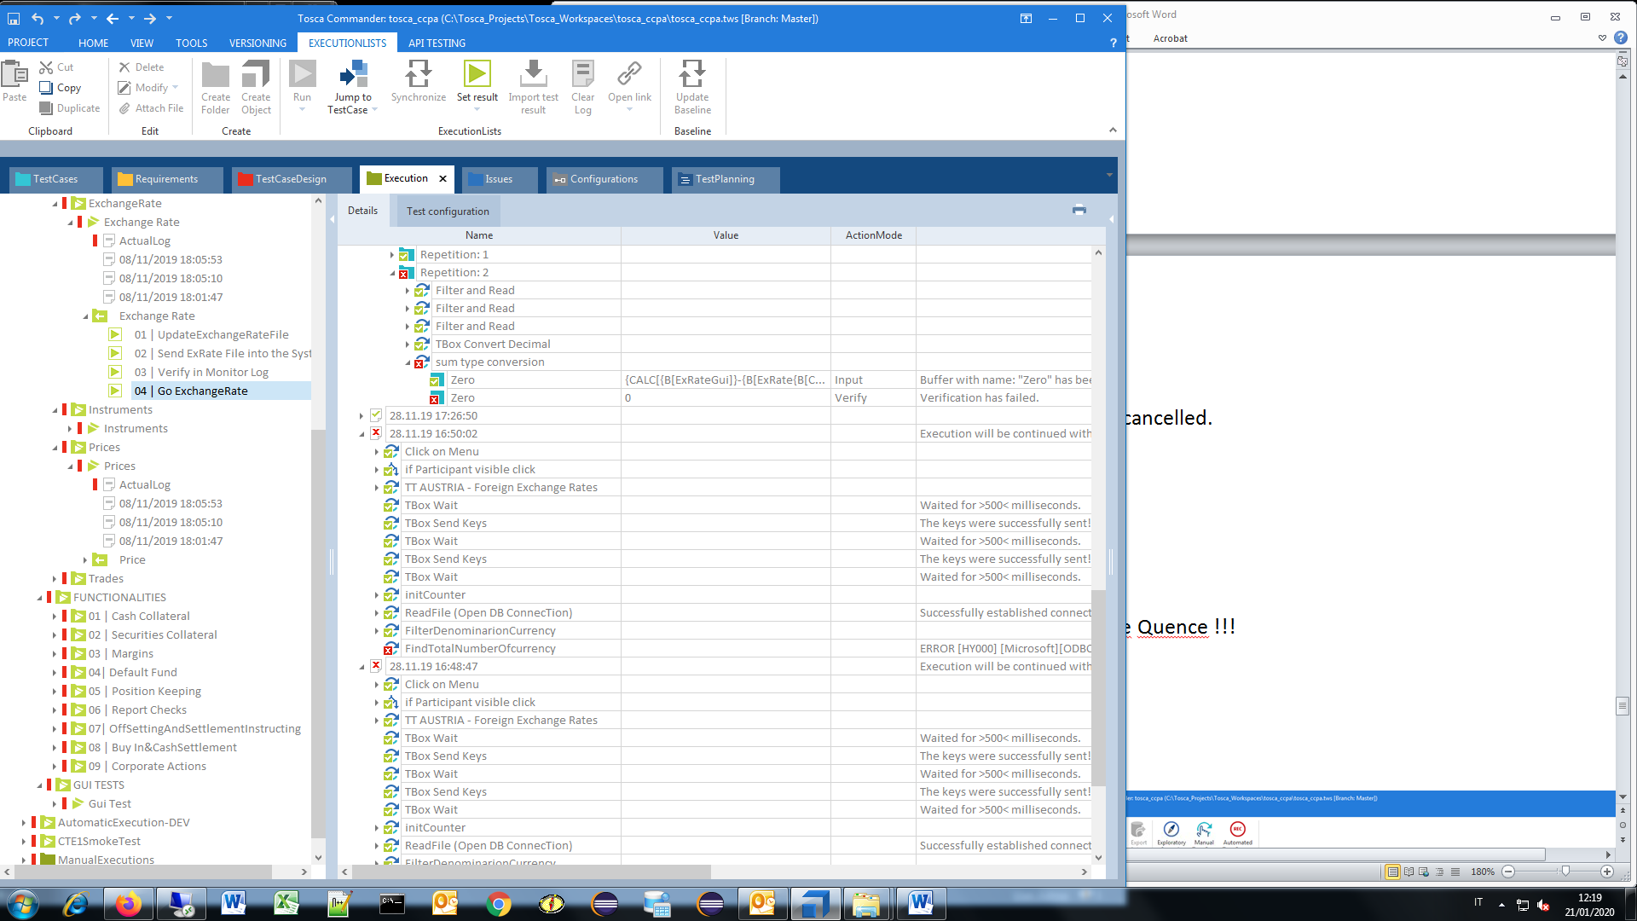

- Username, password, submit button NOT FOUND

4.A) Instruments, Send Instrument, TBox CopyFile

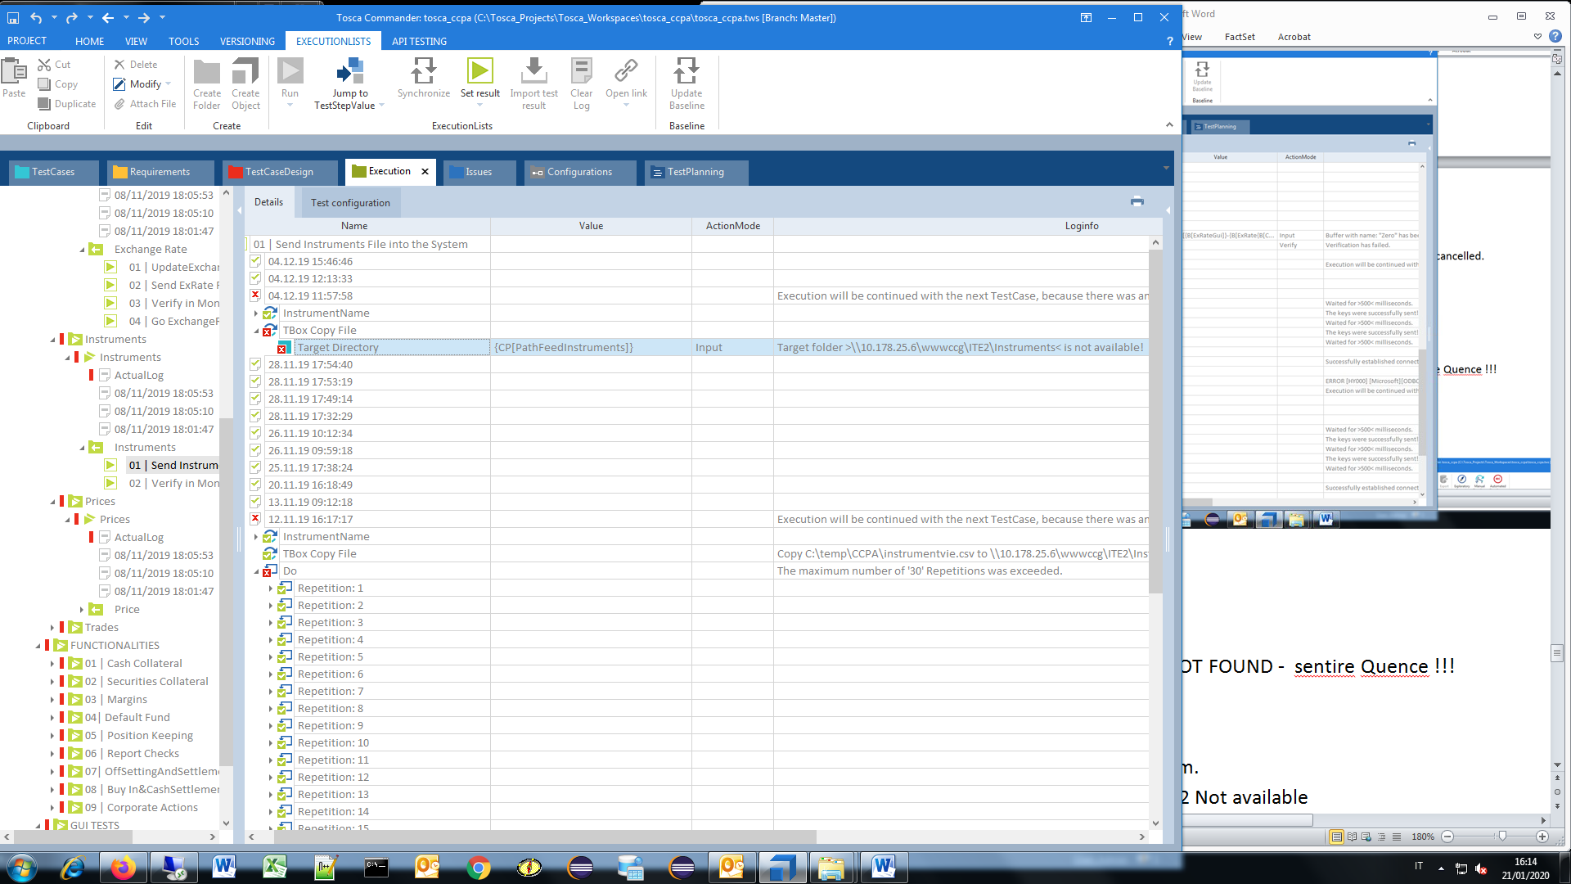

Target folder >\\10.178.25.6\wwwccg\ITE2\Instruments< is not available!

4.B) Instruments, Send Instrument, TBox CopyFile

Execution will be continued with the next TestCase, because there was an error in the current TestCase.

Copy C:\temp\CCPA\instrumentvie.csv to \\10.178.25.6\wwwccg\ITE2\Instruments\instrumentvie20191112.CSV successful - (Overwrite=True)

The maximum number of '30' Repetitions was exceeded

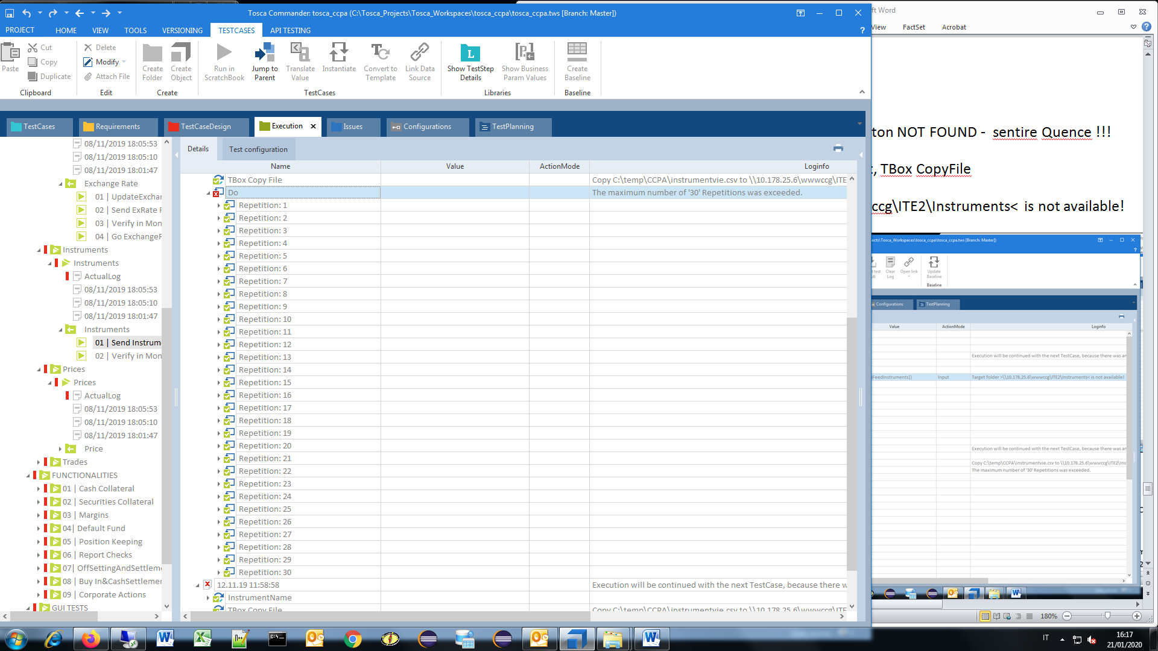

4.C) Instruments, Verify in Monitor Log, Login Credentials

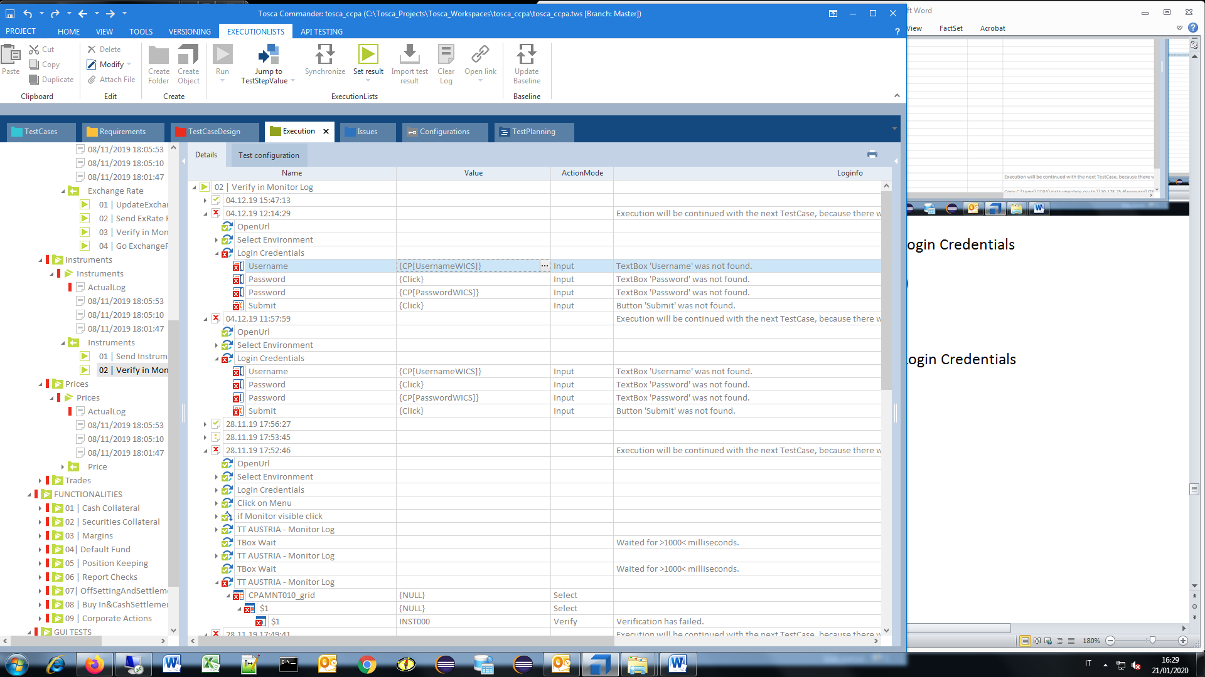

Username, Password, Submit (user WICS)

4.D) Instruments, Verify in Monitor Log, TT AUSTRIA – Monitor Log

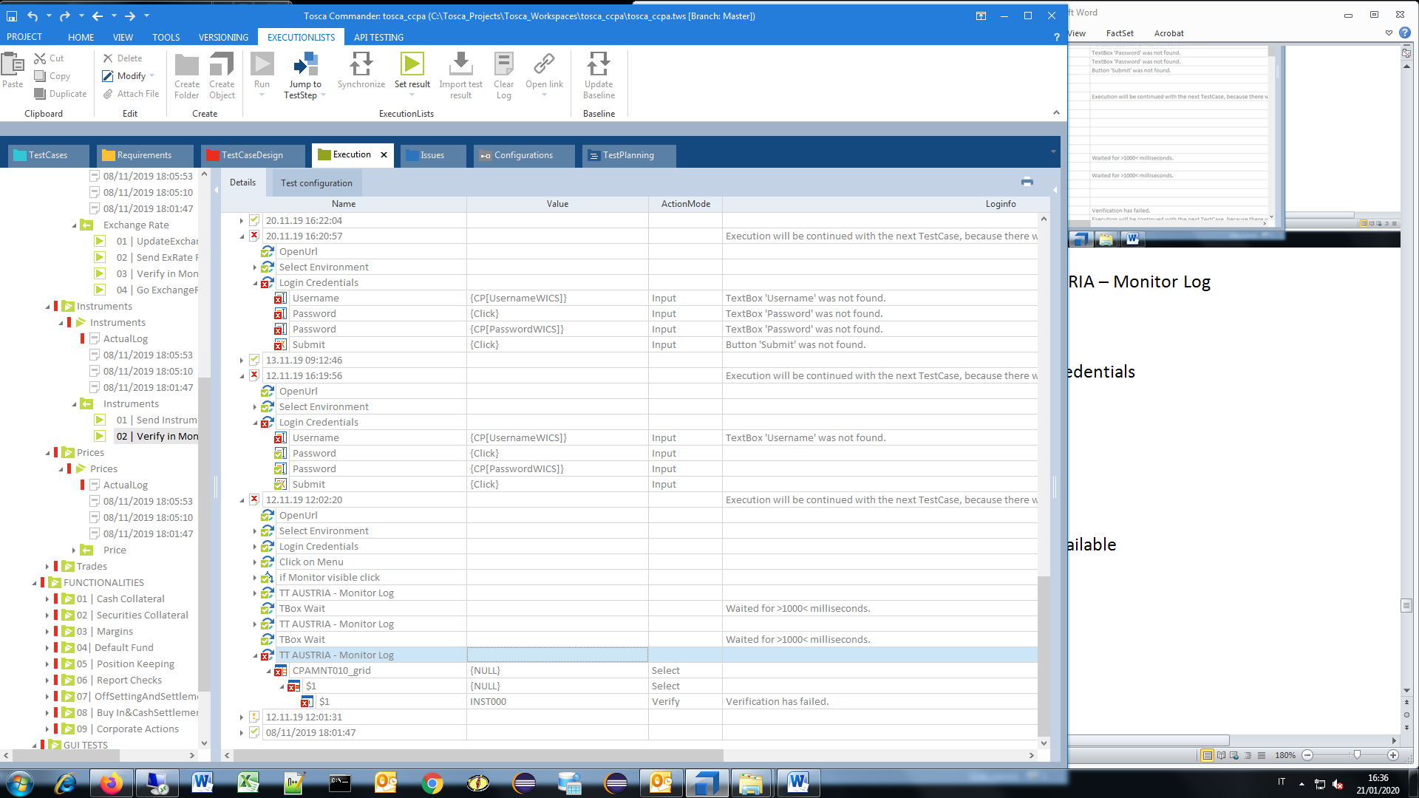

4.E) Instruments, Verify in Monitor Log, TT AUSTRIA – Monitor Log, Verify

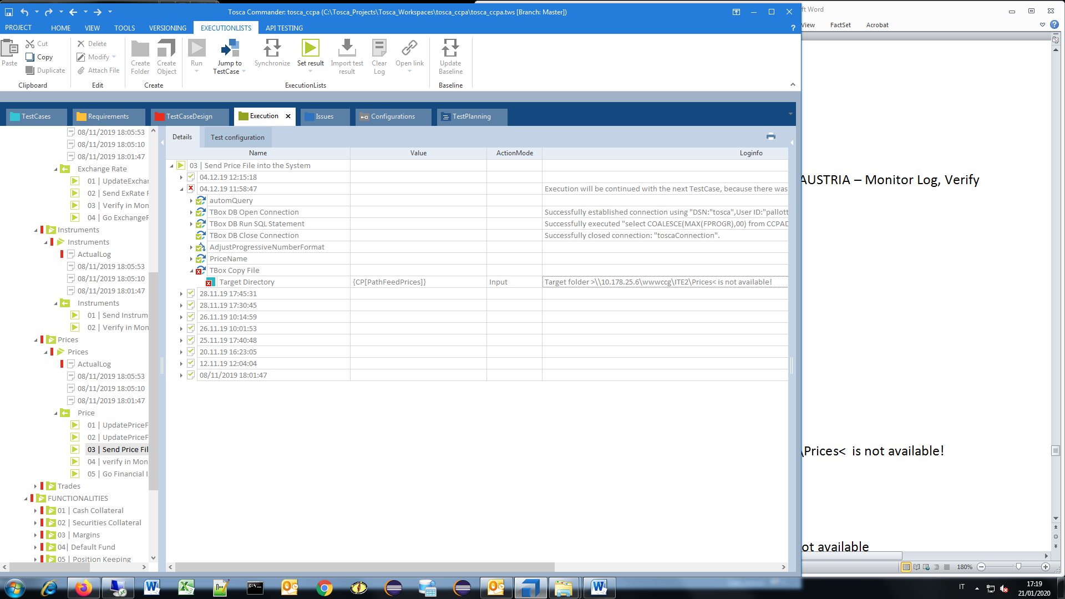

{CP[PathFeedPrices]}, Target folder >\\10.178.25.6\wwwccg\ITE2\Prices< is not available!

5.A) Prices, Price, Send Price File into the System Target Directory

Target folder >\\10.178.25.6\wwwccg\ITE2\Prices< is not available!

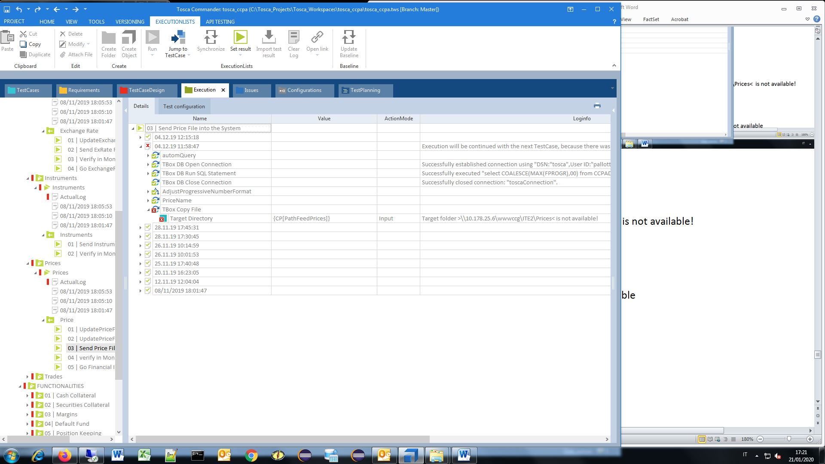

5.B ) Prices, Price, Verify in Monitor Log, TT AUSTRIA - Monitor Log

- CPAMNT010_grid

PRICES0, Verification has .

Expected value == "PRICES0"

Actual value: "CHK-03"

* END OF PRICES FILE: {B[PricesVieName]}, Verification has .
* Expected value == "END OF PRICES FILE: pricesvie20191204115849_02.txt"
* Login Credentials

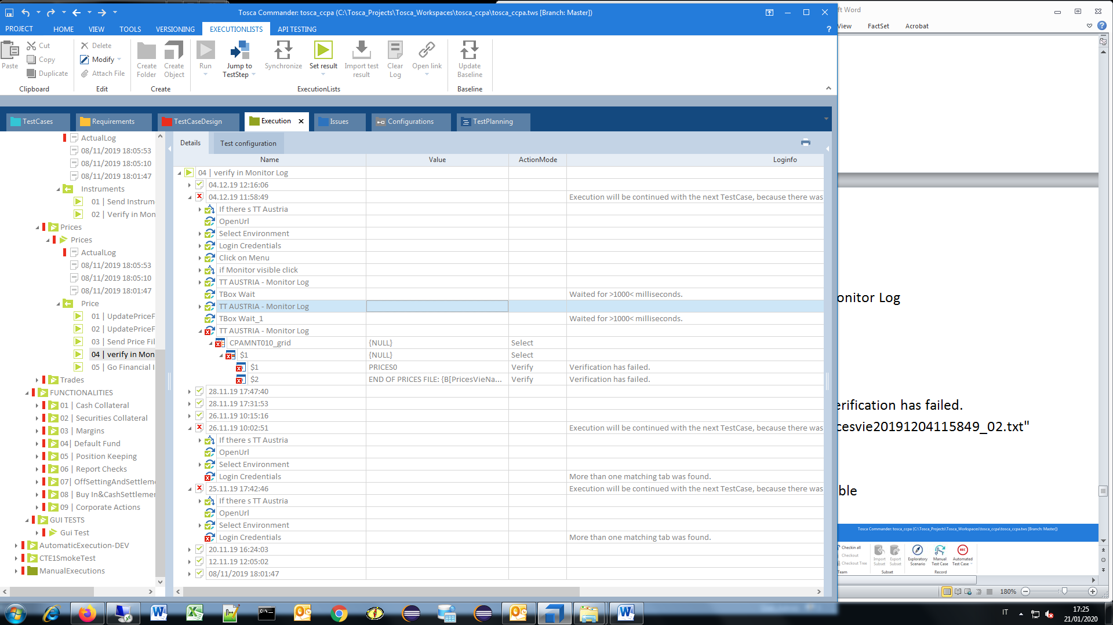

5.C) Prices, price, Verify in Monitor Log, TBox Evaluation Tool

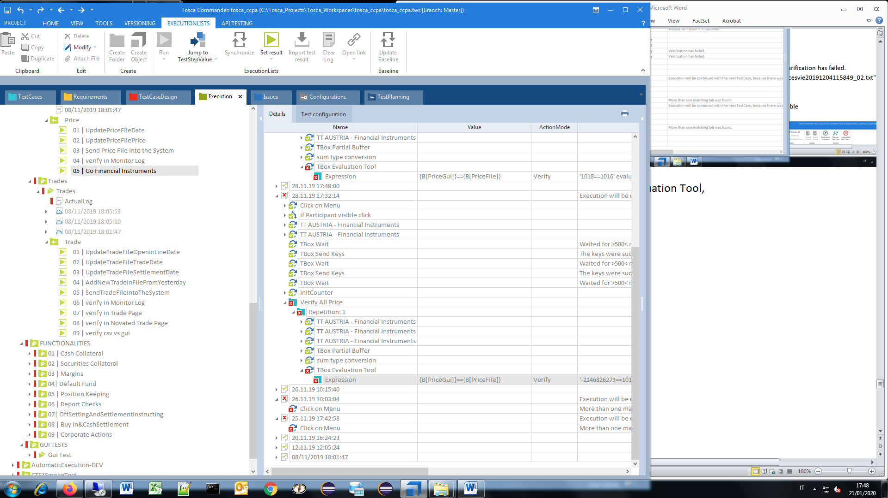

{B[PriceGui]}=={B[PriceFile]},

'1018==1016' evaluated to 'False'

5.D) Prices, price, Go Financial Instruments

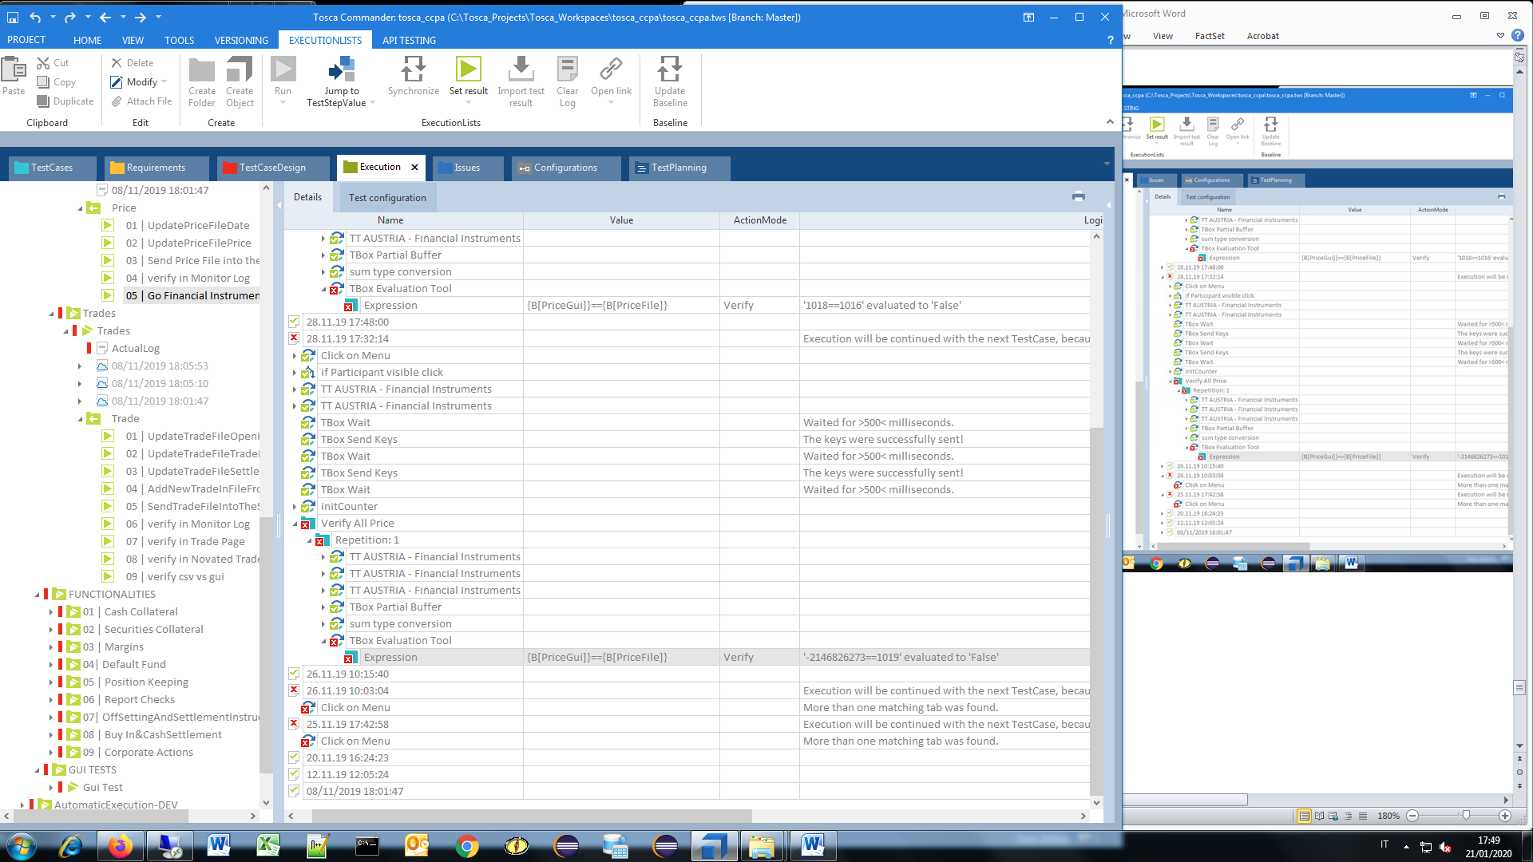

- Click on Menu, More than one matching tab was found.

Execution will be continued with the next TestCase, because there was an error in the current TestCase.

6.A) Trades, trade, SendTradeFileIntoTheSystem

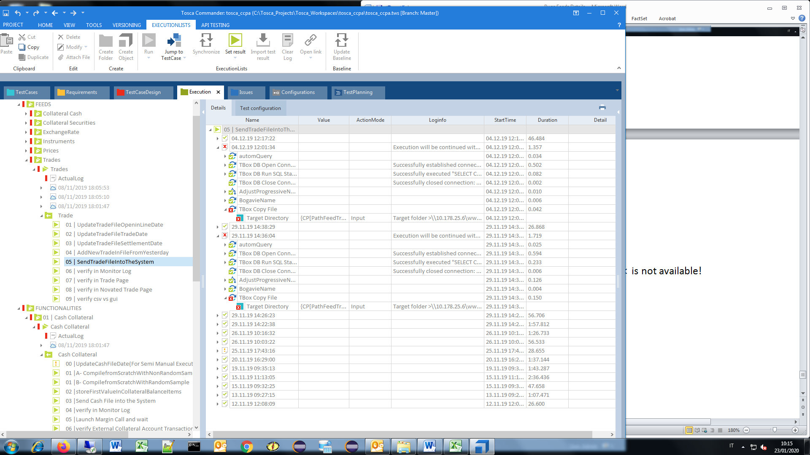

- Target Directory, 10.178.25.6\wwwccg\ITE2\Trades< is not available!

6.B) Trades, trade, Verify ID Operazione

- CPAMNT010_grid, TRAD000, END OF TRADES FILE: {B[BogavieName]}.DAT, Verification has .

Expected value == "END OF TRADES FILE: bogavie20191204_01.DAT"

- Select Environment, No matching tab was found,

- Login Credentials, Username, Password (click), Submit (Click), Button 'Submit' was not found

- Login Credentials, More than one matching tab was found

6.C) Trades, trade, Verify in Trade Page

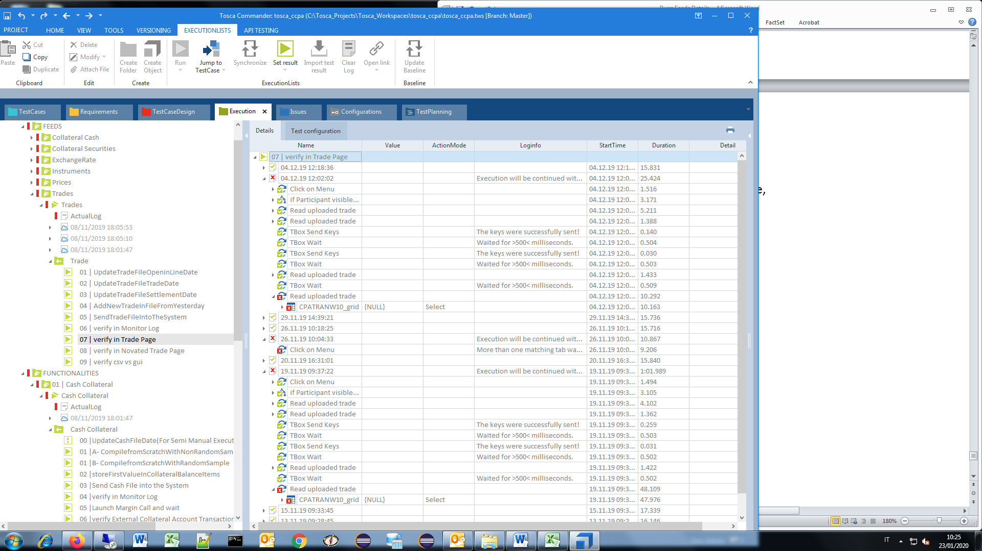

-Read uploaded trade,

-CPATRANW10_grid,

Click on Menu, More than one matching tab was found,

Execution will be continued with the next TestCase, because there was an error in the current TestCase.

6.D) Trades, trade, Verify in Trade Page, verify in Novated Trade.

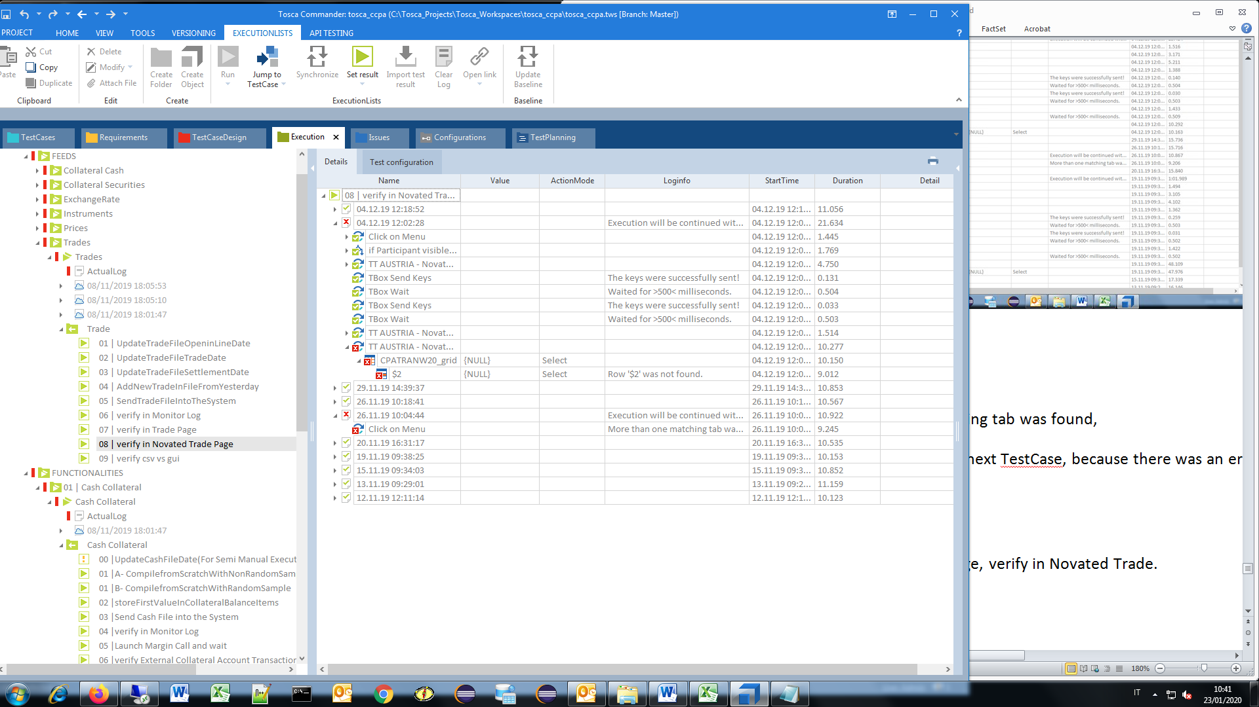

- TT AUSTRIA - Novated Trade,

- CPATRANW20_grid, Select, Row '$2' was not found.

-Click on Menu, More than one matching tab was found.

6.E) Trades, trade, verify csv vs gui

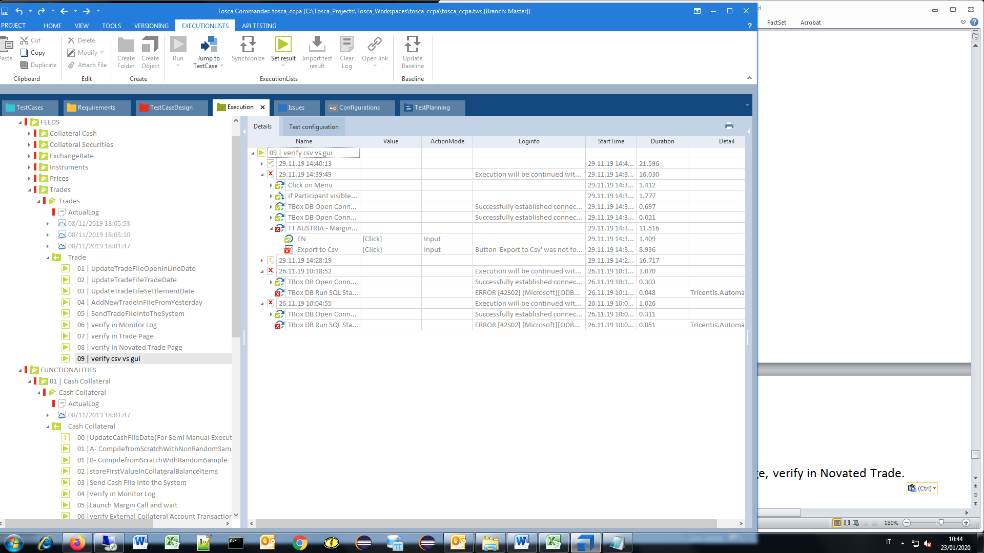

* Button ‘Export to Csv’ was not found…

7.A) FUNCTIONALITIES, Cash Collateral, UpdateCashFileDate(For Semi Manual Execution)

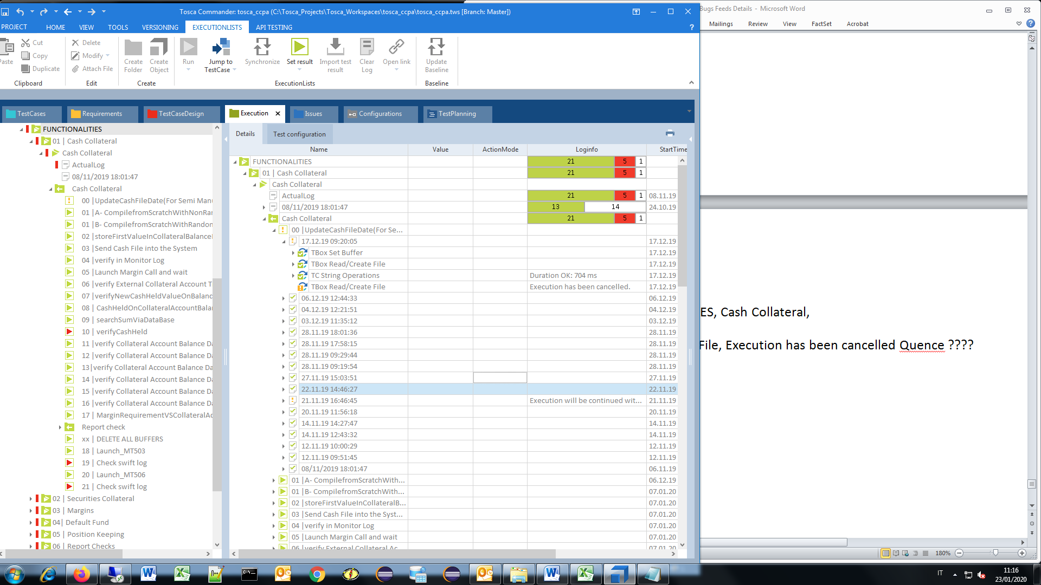

TBox Read/Create File, Execution has been cancelled

7.B) FUNCTIONALITIES, Cash Collateral, verifyCashHeld

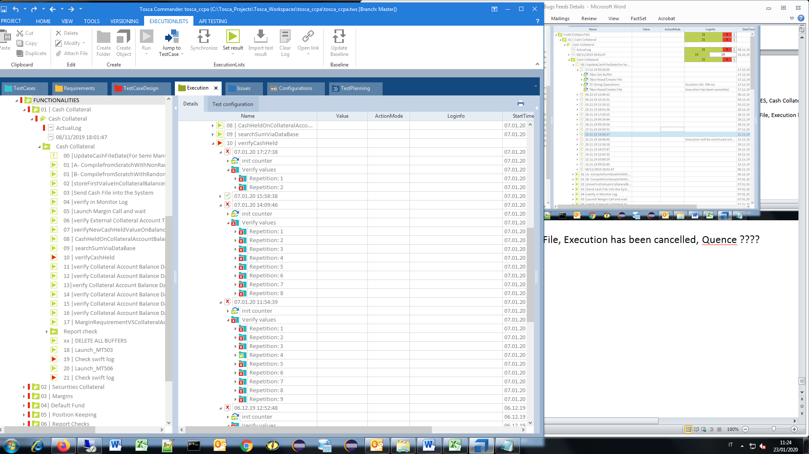

* Verify values, Repetition: 1

Verify (sumBalanceItems, CashHeld [Counter],

Verification has .

Expected value == "125.359,51"

Actual value: "126.659,51"

* Verify values, Repetition: 2

Verification has .

Expected value == "1.030,96"

Actual value: "2.930,96"

….

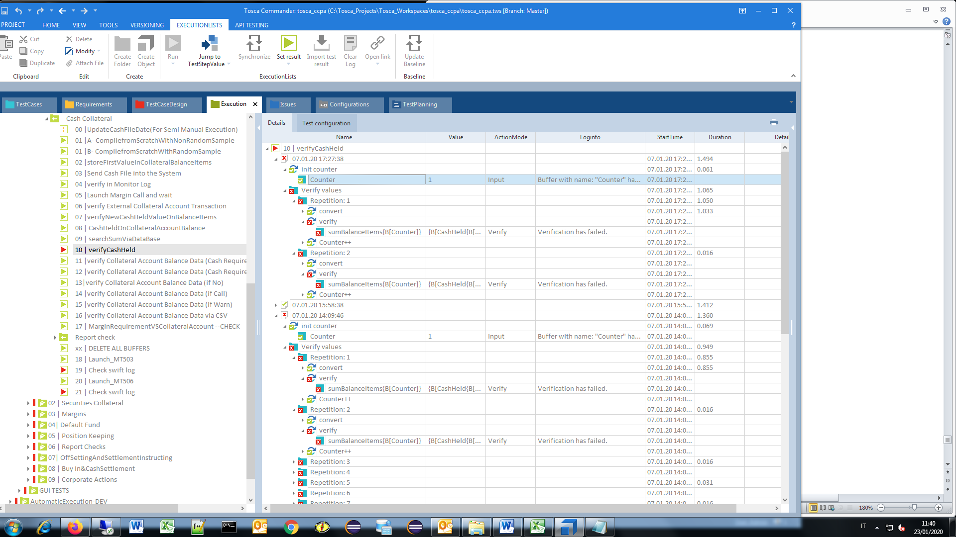

7.C) FUNCTIONALITIES, Cash Collateral, Check swift log

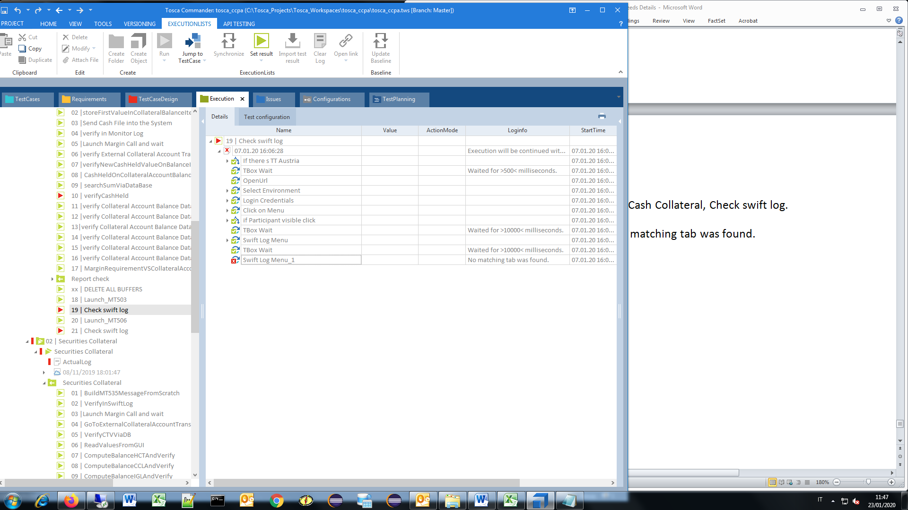

- Swift Log Menu_1, No matching tab was found

8.A) Securities Collateral, VerifyInSwiftLog

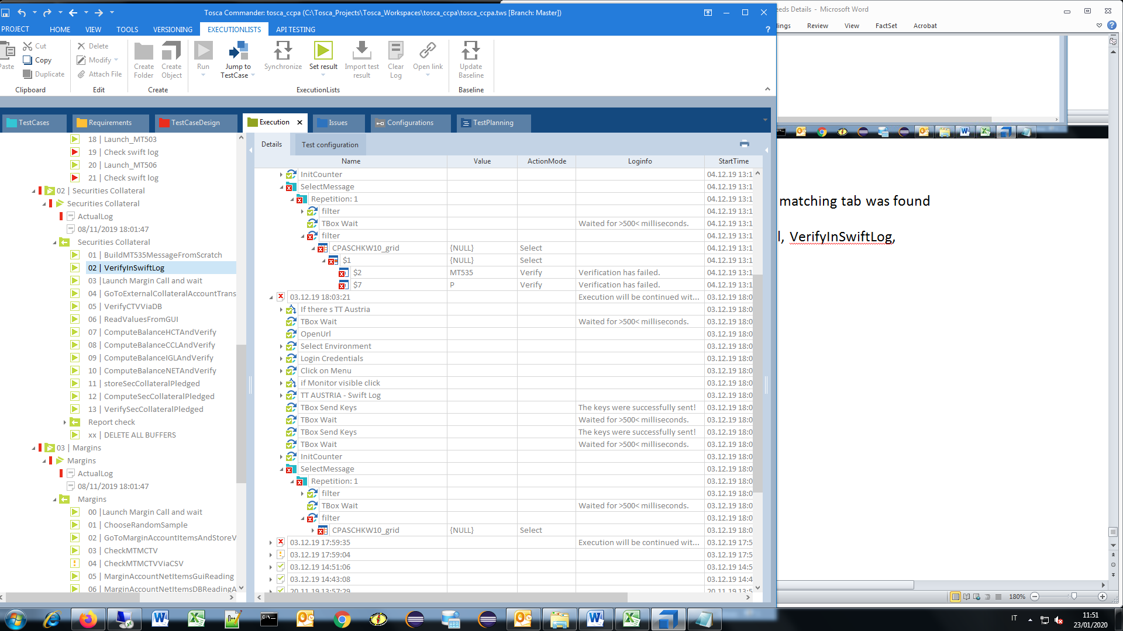

* CPASCHKW10_grid,

($2)Verification has .

Expected value == "MT535"

Actual value: "MT202"

($7)Verification has .

Expected value == "P"

Actual value: "A"

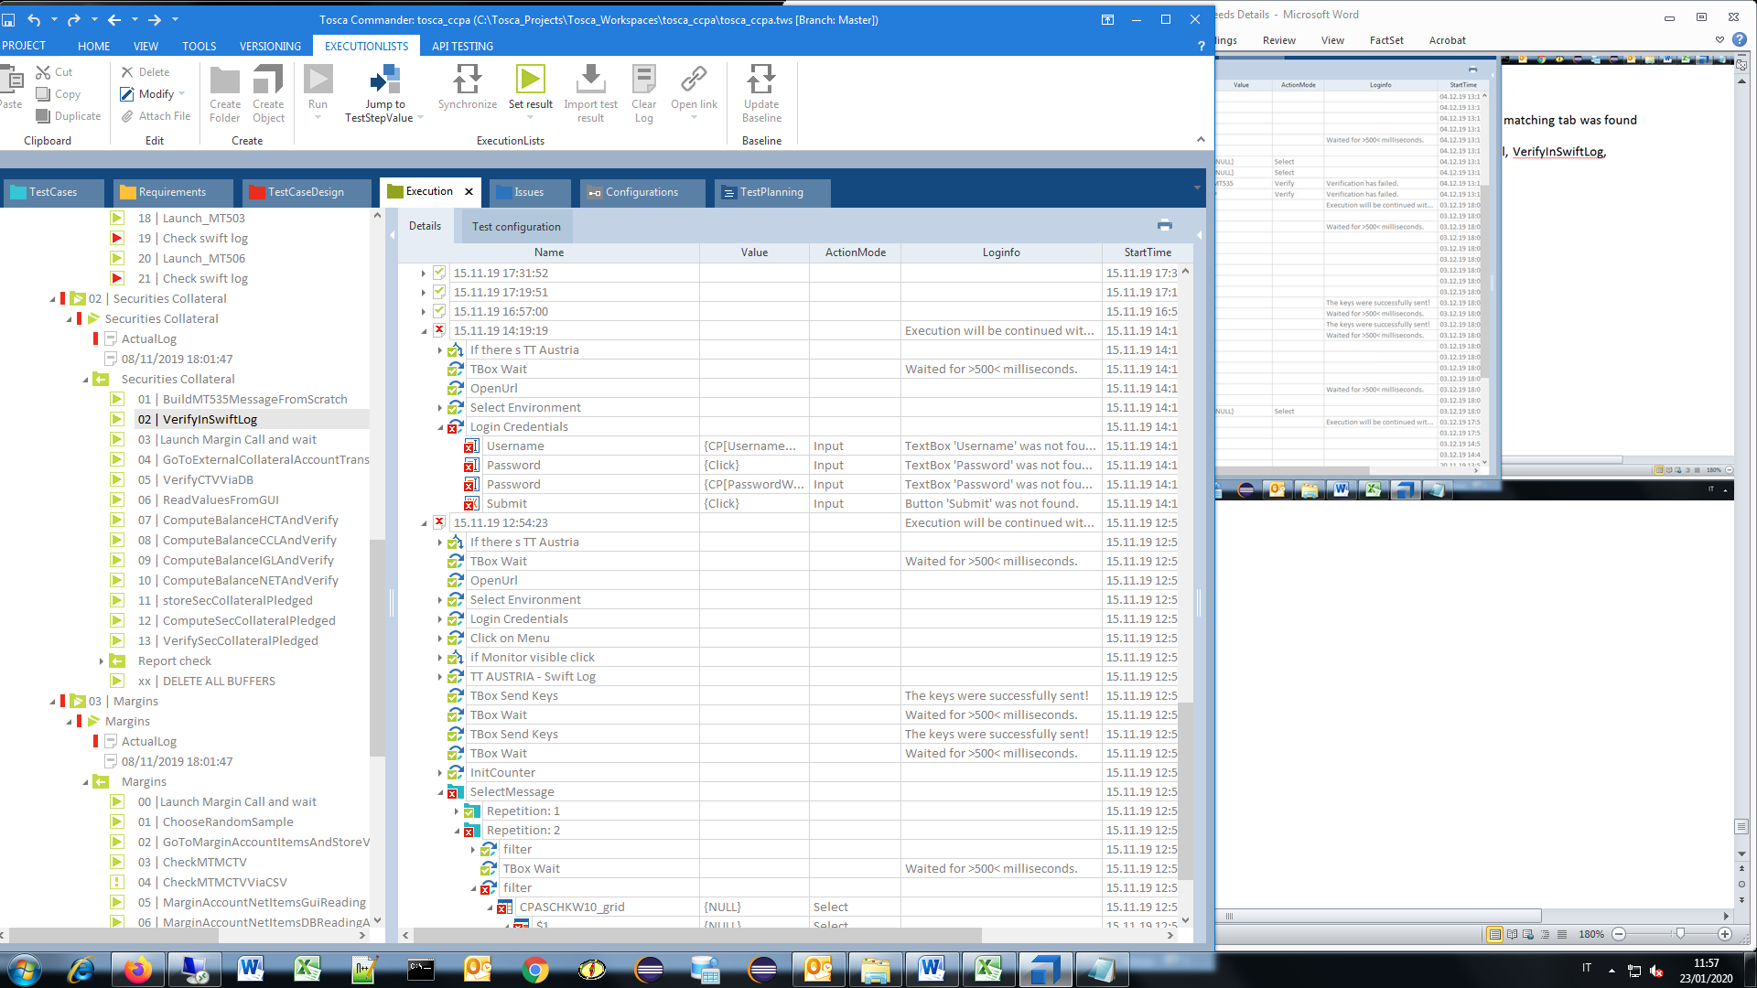

8.B) Securities Collateral, Launch Margin Call and wait

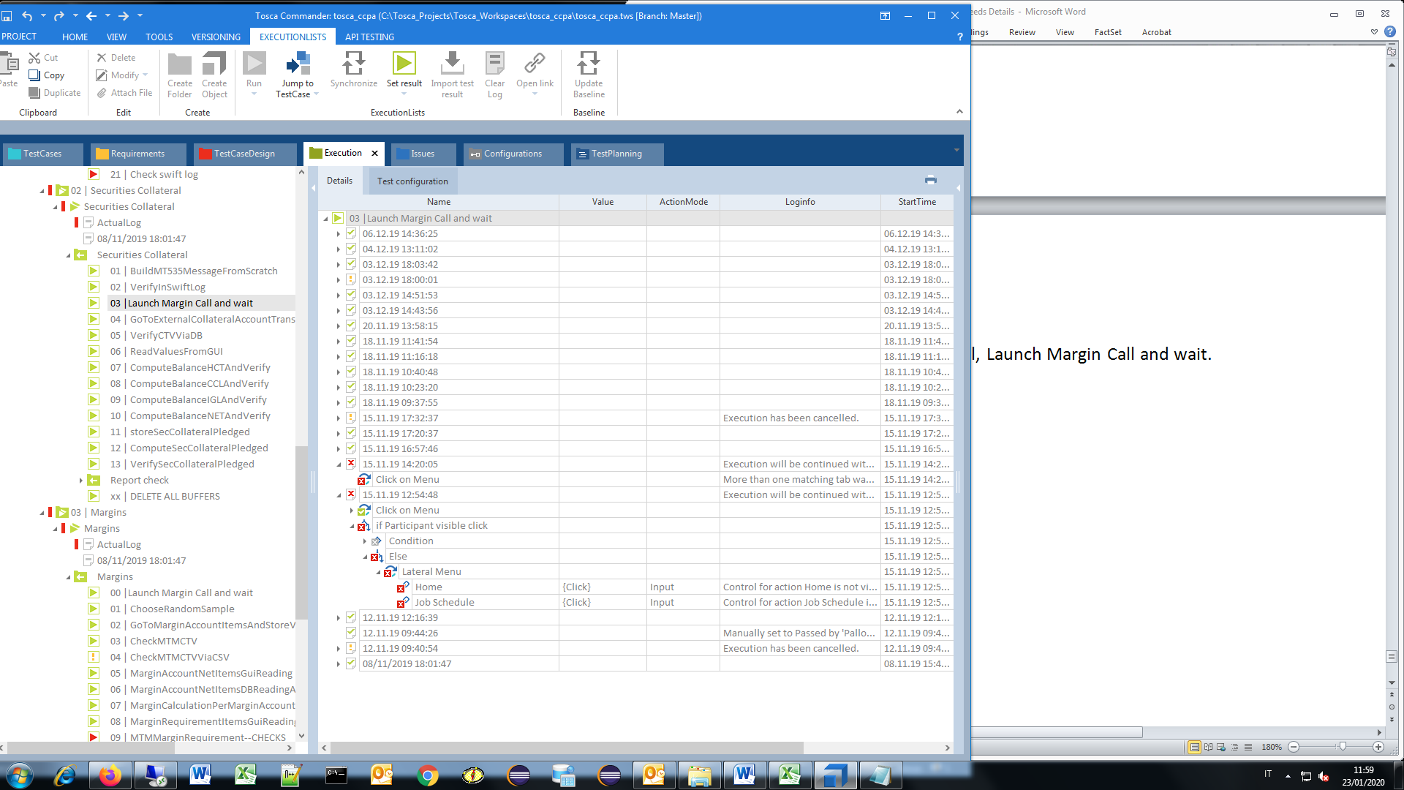

* Click on Menu, Execution will be continued with the next TestCase, because there was an error in the current TestCase,
* Home, Control for action Home is not visible,
* Job Schedule, Control for action Job Schedule is not visible,
* Select Environment, The application under test seems to be not responding. Timeout has been exceeded while receiving a response.

8.C) Securities Collateral, GoToExternalCollateralAccountTransactionAndBufferData

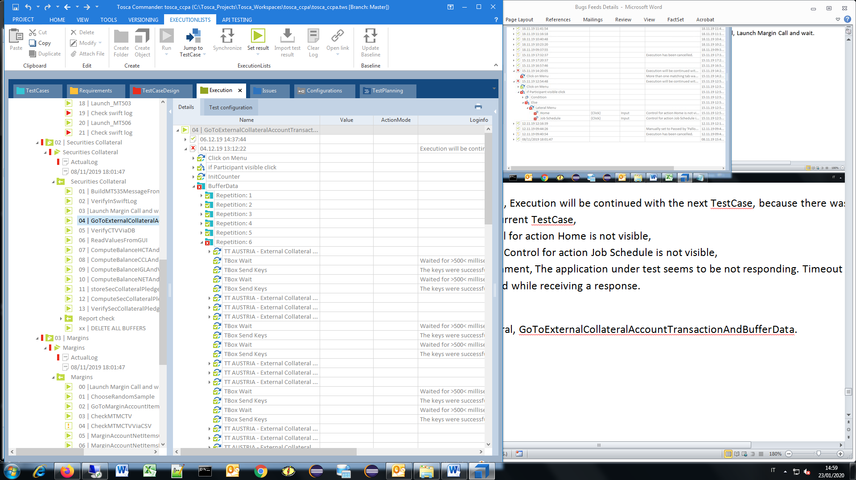

* TT AUSTRIA - External Collateral Account Transactions,

CPADEPT010_grid,

$1, Row '$1' was not found.

* BufferData

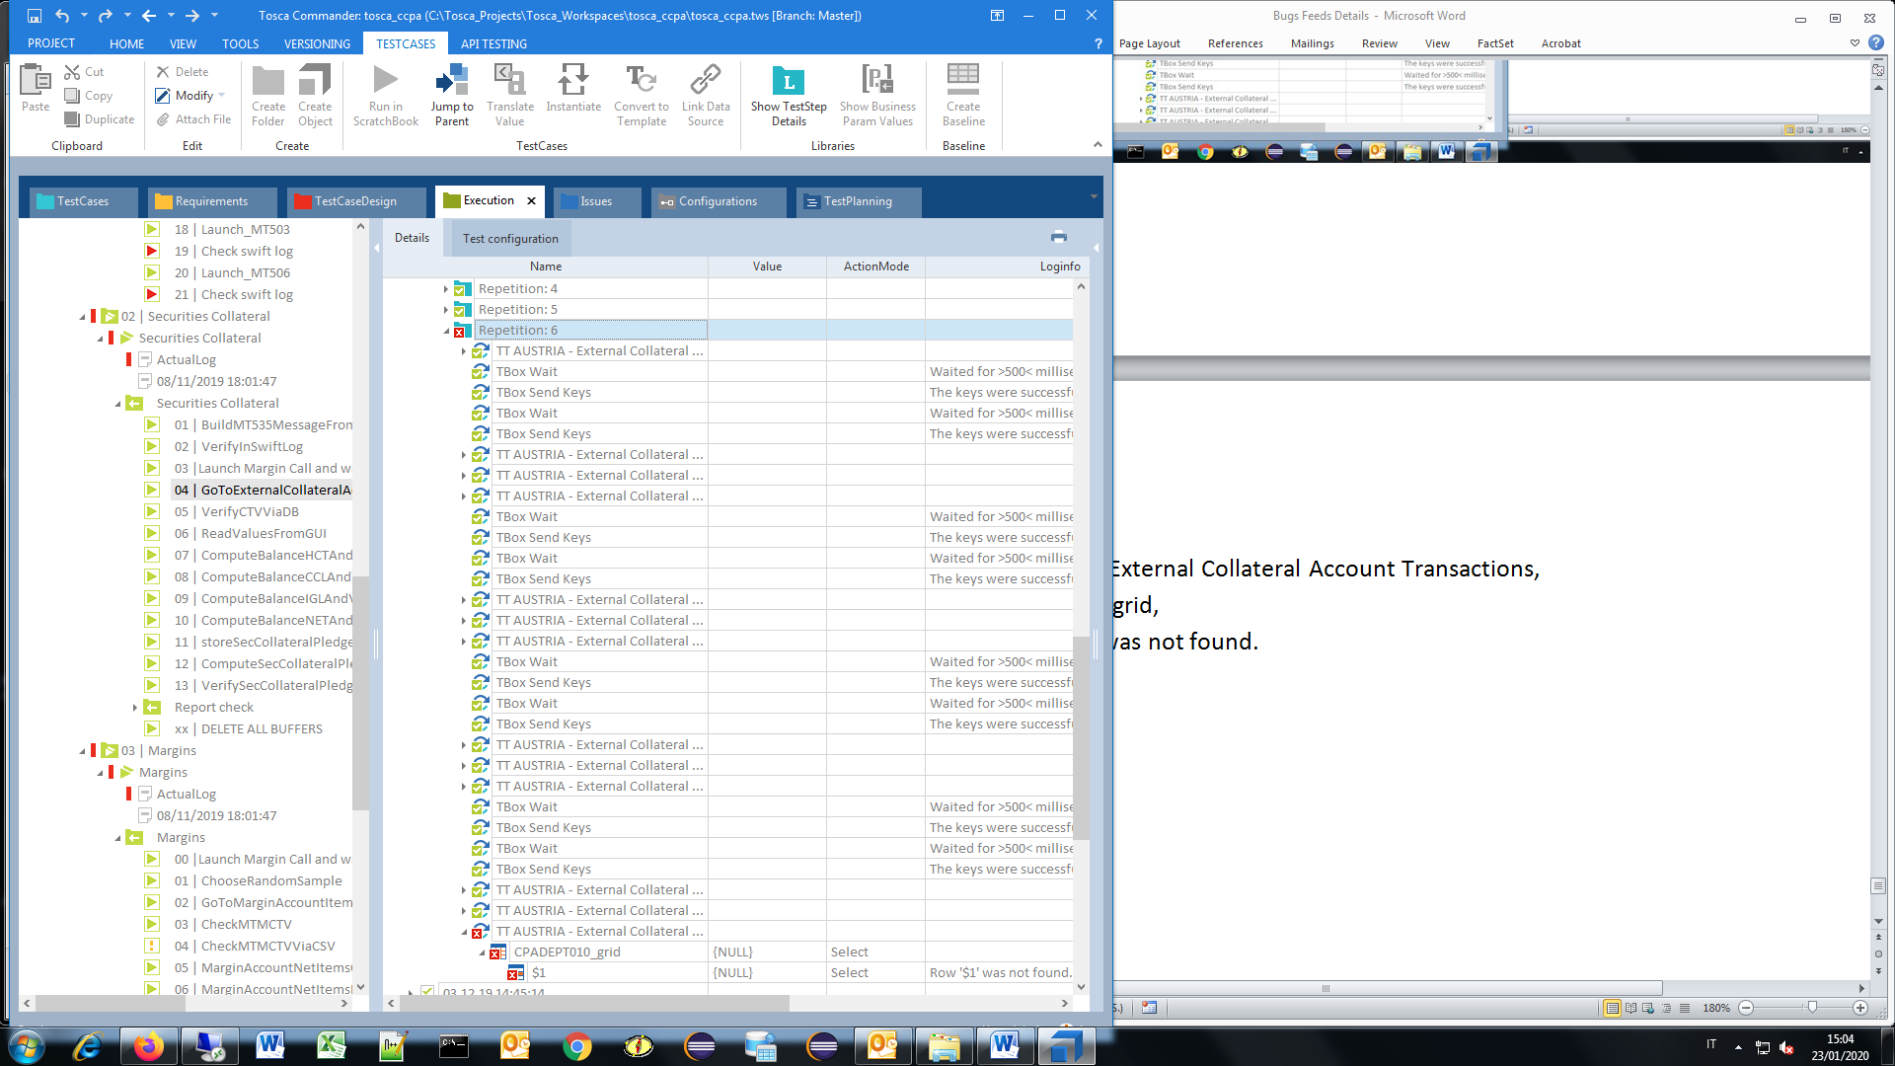

-Collateral Management,

-External Collateral Management

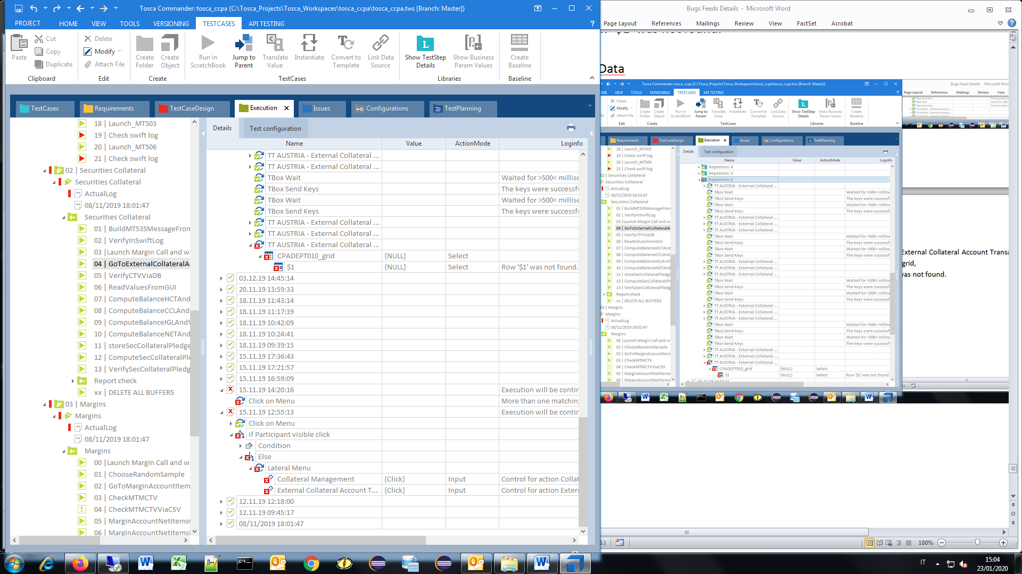

* CPADEPT010_grid,

($1) Row '$1' was not found.

Click on Menu, More than one matching tab was found.

* Collateral Management, {Click}, Control for action Collateral Management is not visible.
* External Collateral Account Transactions, {Click},Control for action External Collateral Account Transactions is not visible.

8.D) Securities Collateral, VerifyCTVViaDB, QueryOnQTY, TBox DB Run SQL Statement

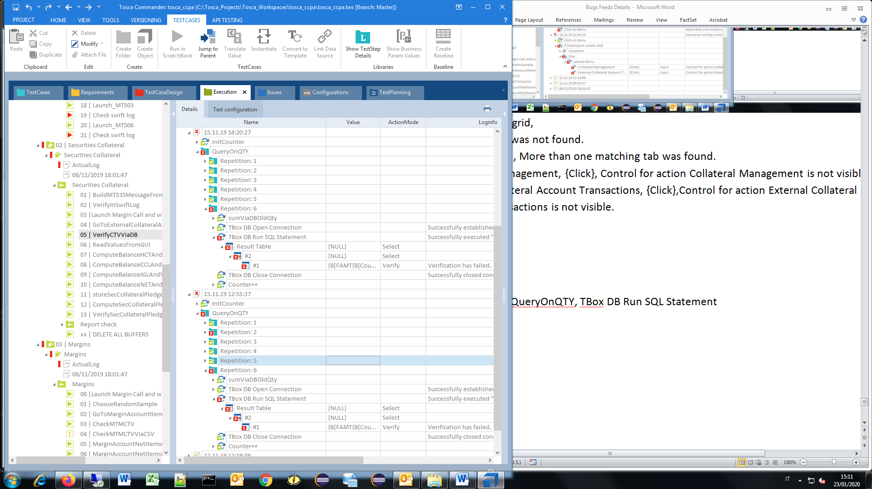

* TBox DB Run SQL Statement

8.E) Securities Collateral, ReadValuesFromGUI

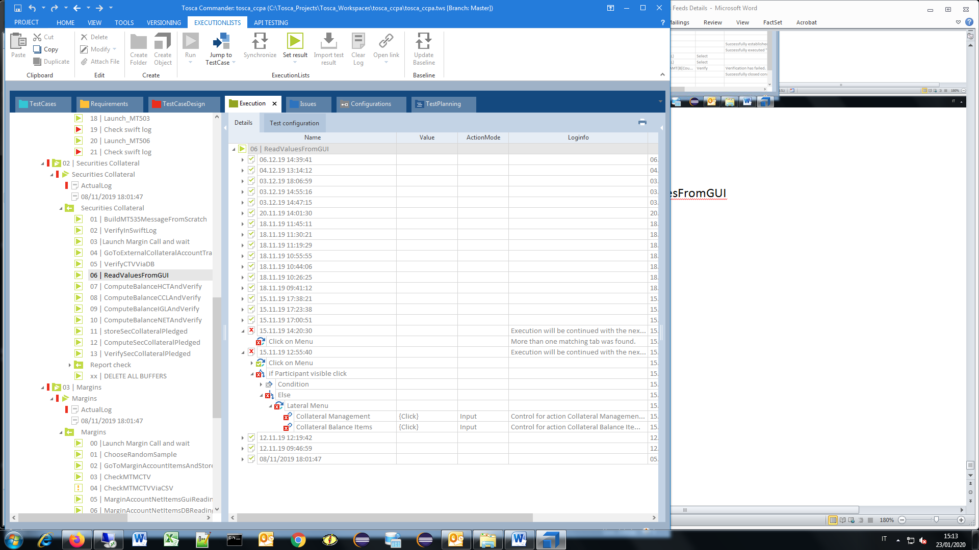

* Collateral Management, Click, Control for action Collateral Management is not visible.
* Collateral Balance Items, Click, Control for action Collateral Balance Items is not visible.

8.F) Securities Collateral, ComputeBalanceHCTAndVerify

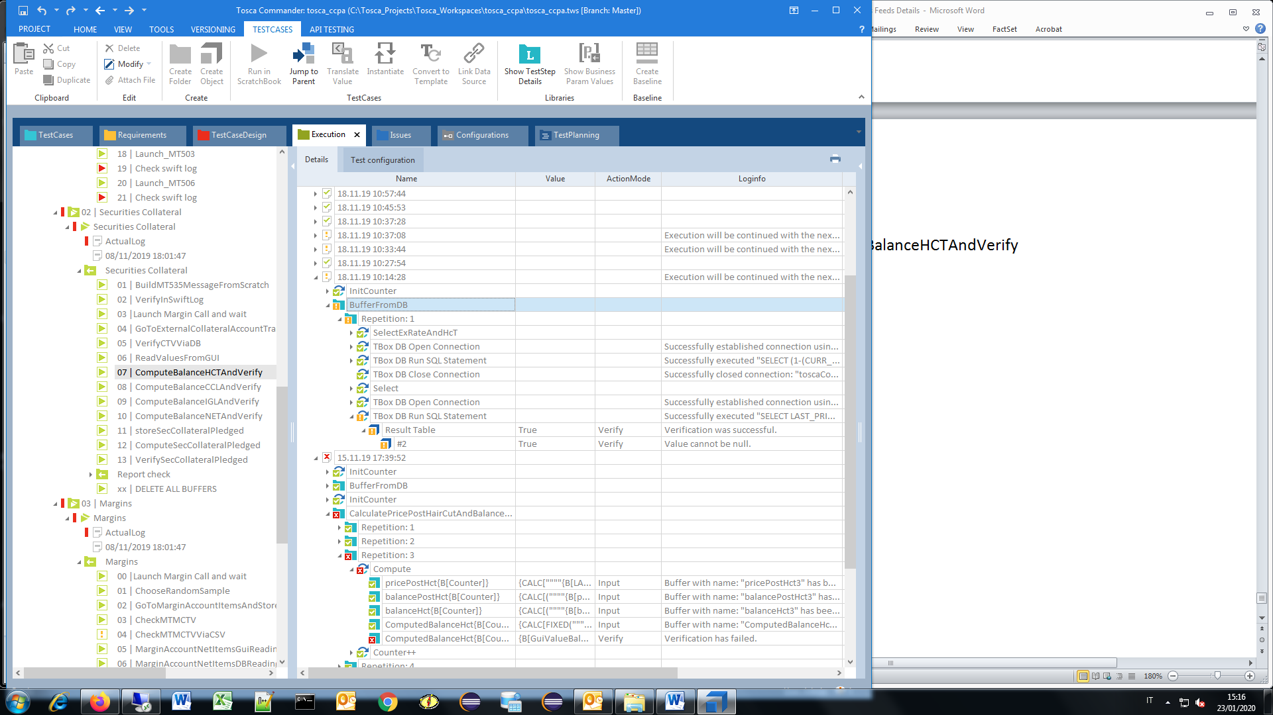

* ComputeBalanceHCTAndVerify,

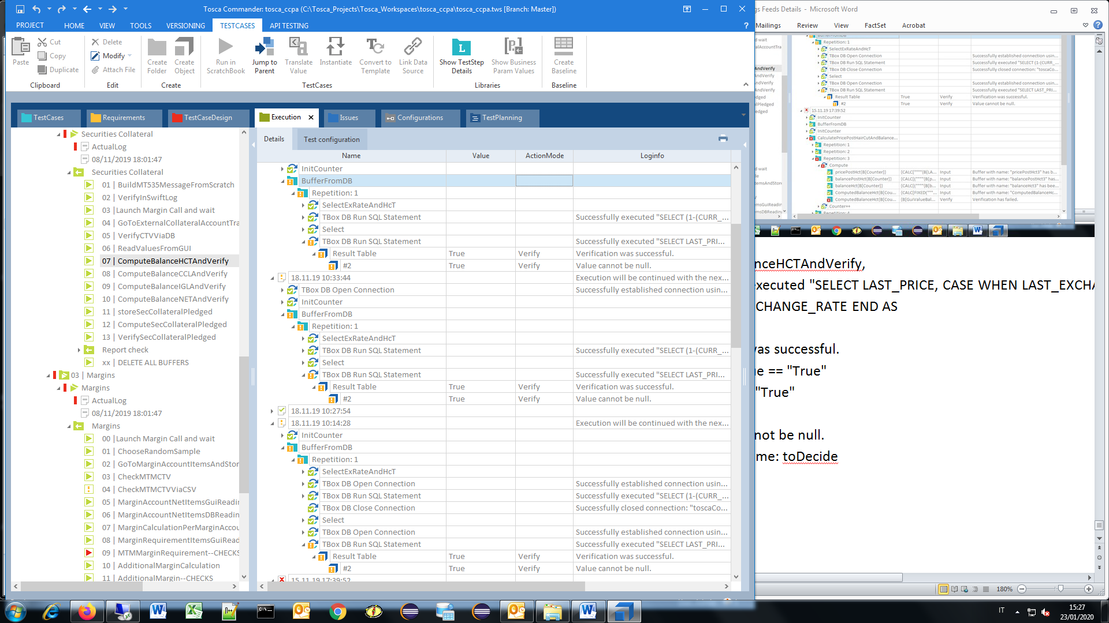

#2, Value cannot be null.

Parameter name: toDecide

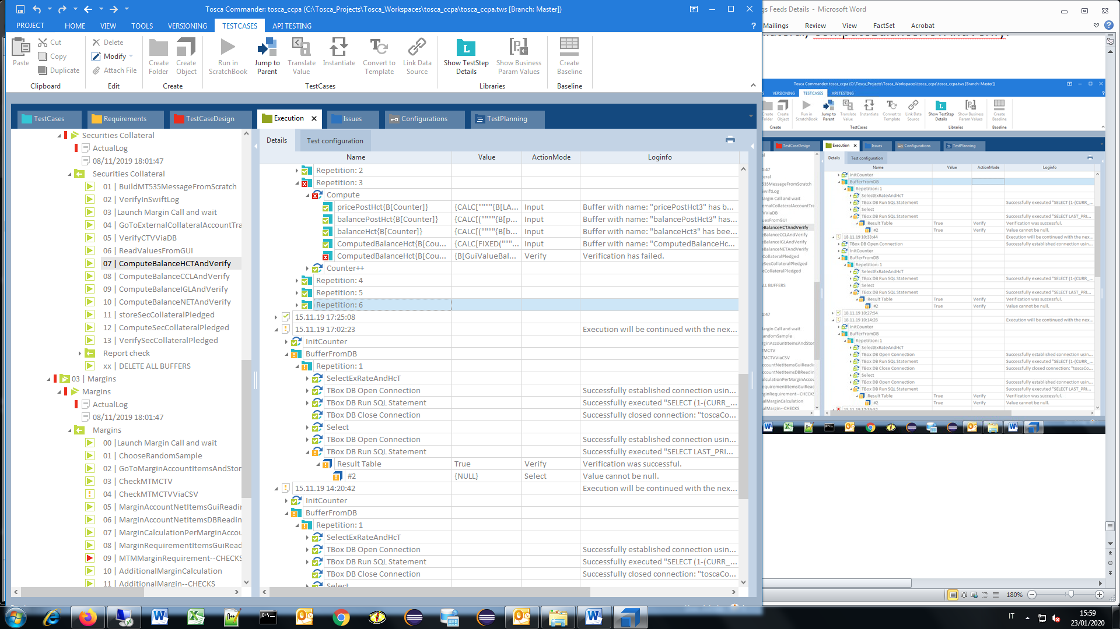

* ComputedBalanceHct, GuiValueBalanceHCT{B[Counter]}]}

Verification has …

8.G) Margins, MTMMarginRequirement—CHECKS

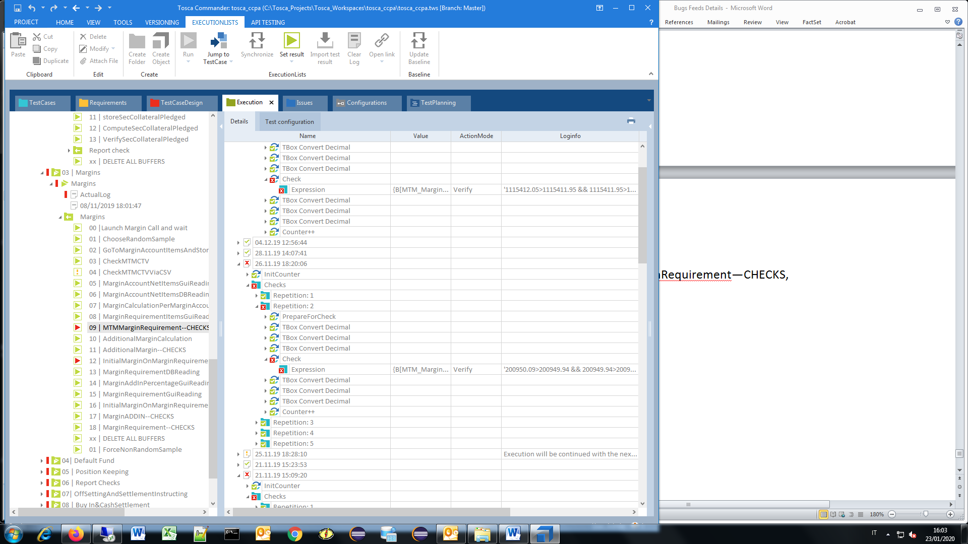

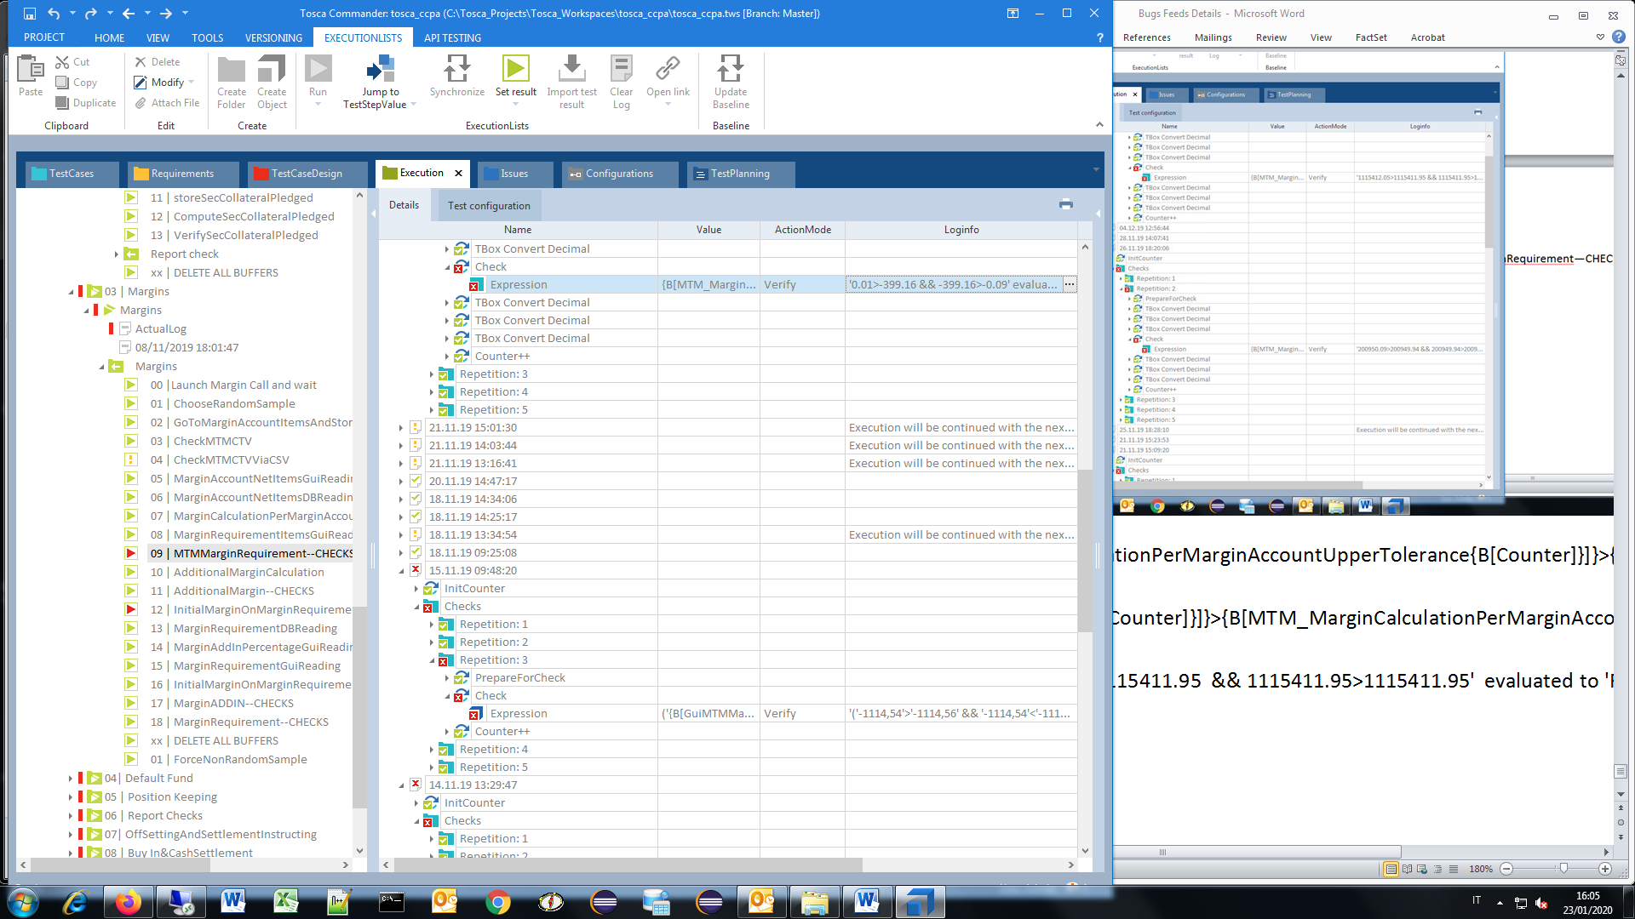

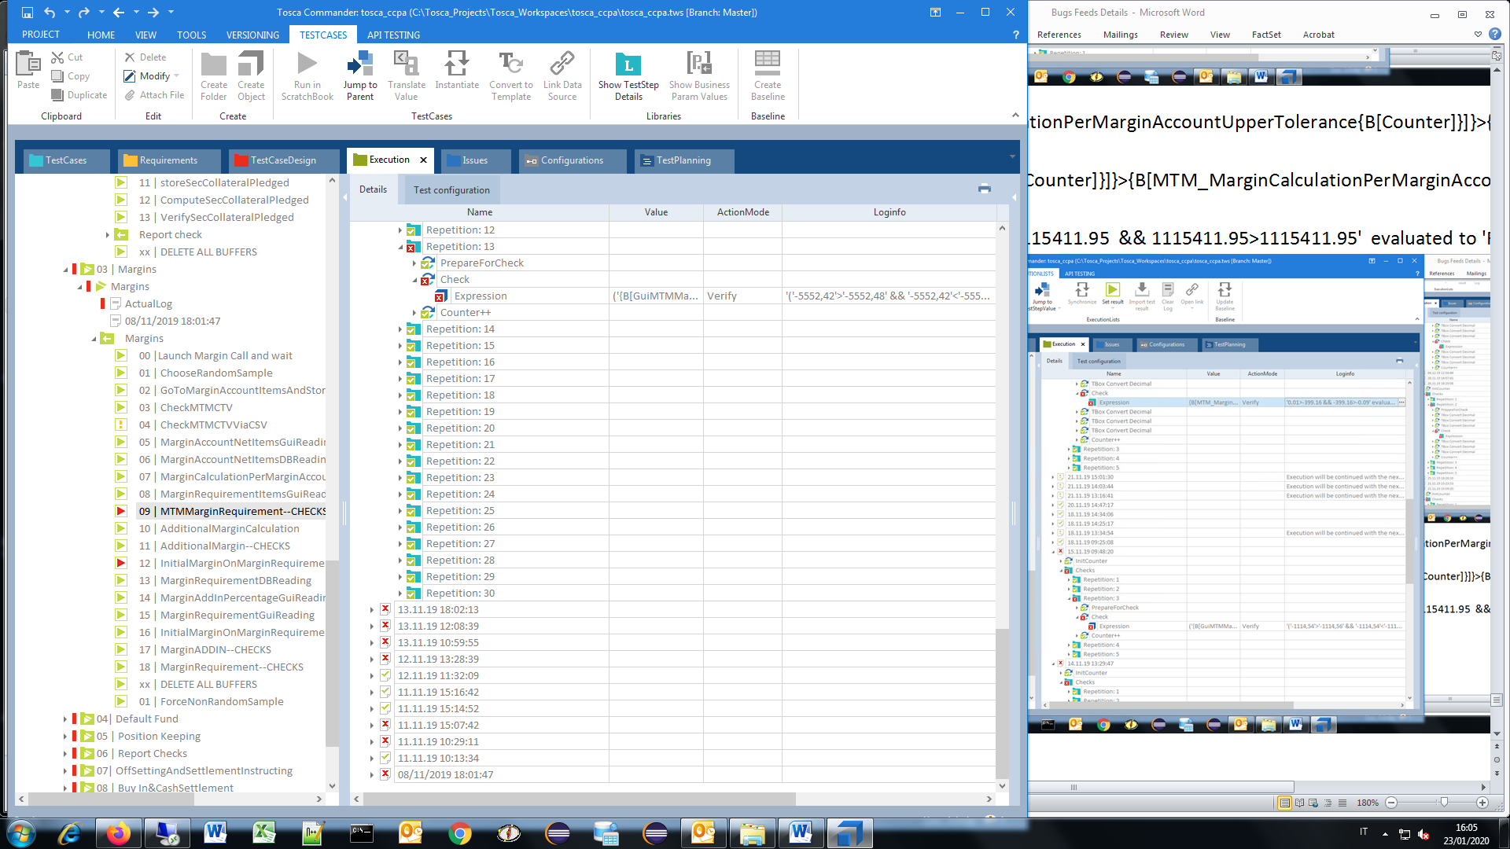

* {[MTM_MarginCalculationPerMarginAccountUpperTolerance{B[Counter]}]}>{B[GuiMTMMargin{B[Counter]}]} && {B[GuiMTMMargin{B[Counter]}]}>{B[MTM_MarginCalculationPerMarginAccountLowerTolerance{B[Counter]}]}
* Verify

9.A) Margins, InitialMarginOnMarginRequirementItems—CHECKS

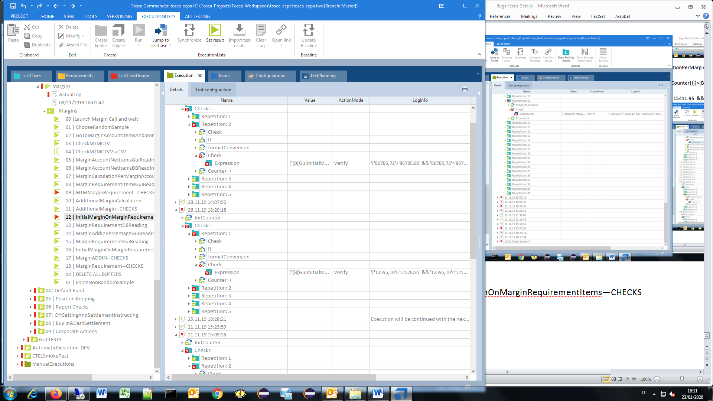

* GuiInitialMargin{B[Counter]}]}'>'{B[ComputedInitialMarginLowerTolerance{B[Counter]}]}'

Verify, '('86785,72'>'86785,80' && '86785,72'<'86785,90' ) ||'86785,72'=='86785,85'' evaluated to 'False

* GuiInitialMargin{B[Counter]}]}'>'{B[ComputedInitialMarginLowerTolerance{B[Counter]}]}'

Verify, '('12595,10'>'12578,95' && '12595,10'<'12579,05' ) ||'12595,10'=='12579,00'' evaluated to 'False'

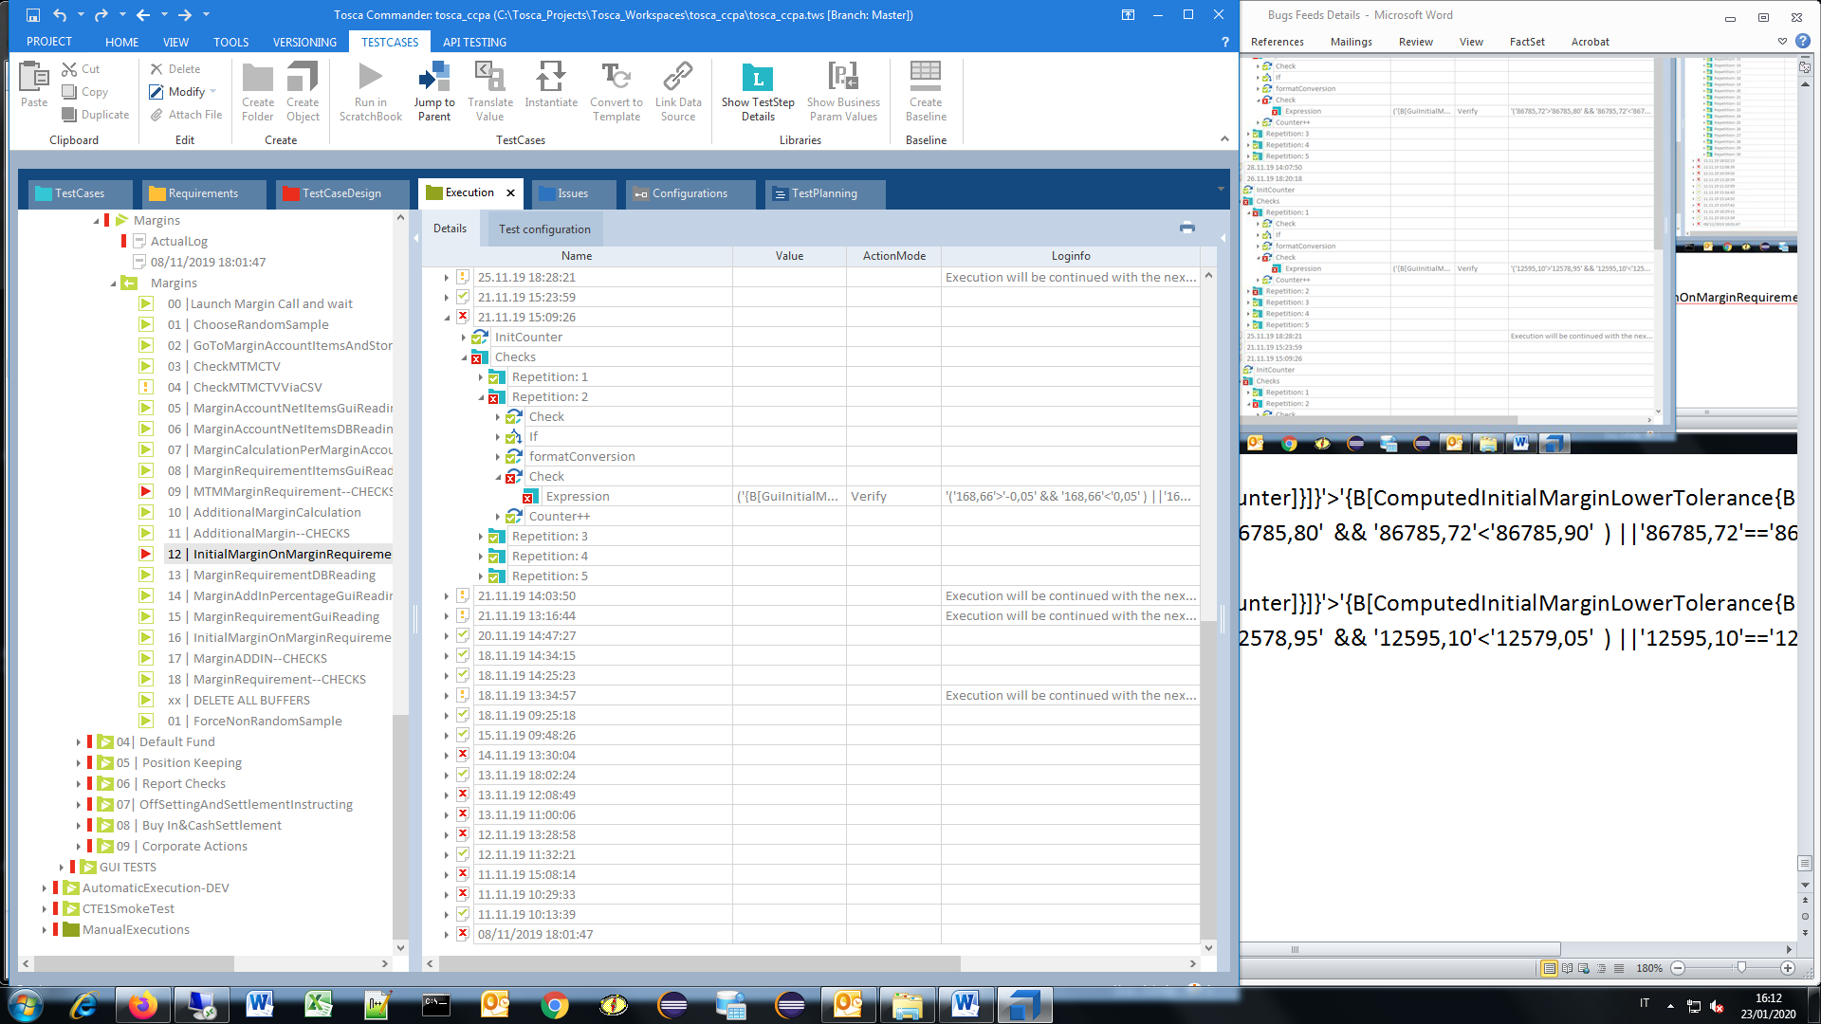

* Check, GuiInitialMargin{B[Counter]}]}'>'{B[ComputedInitialMarginLowerTolerance{B[Counter]}]}', '('168,66'>'-0,05' && '168,66'<'0,05' ) ||'168,66'=='0,00'' evaluated to 'False'

9.B) Margins, MS36ReportCheck

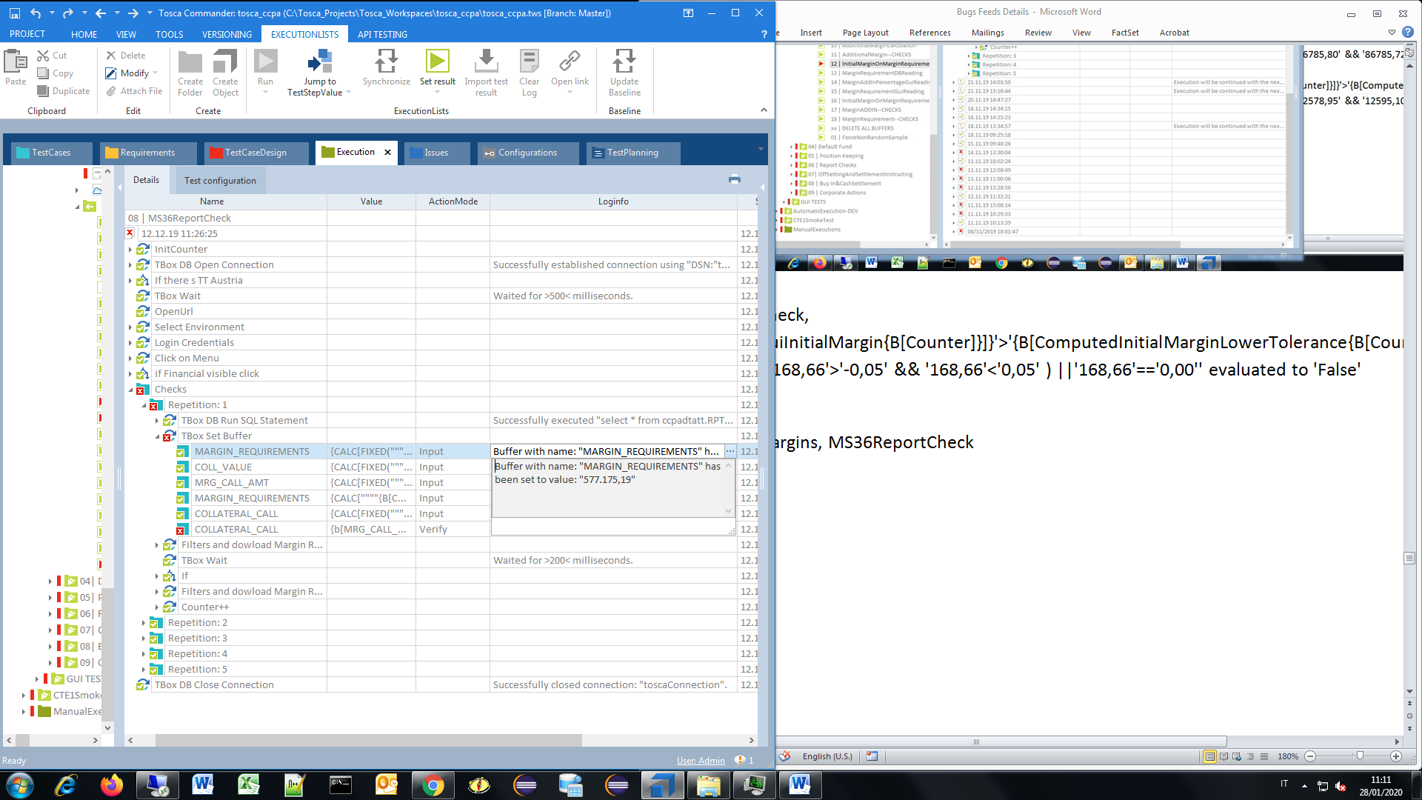

-Buffer with name: "MARGIN_REQUIREMENTS" has been set to value: "577.175,19"

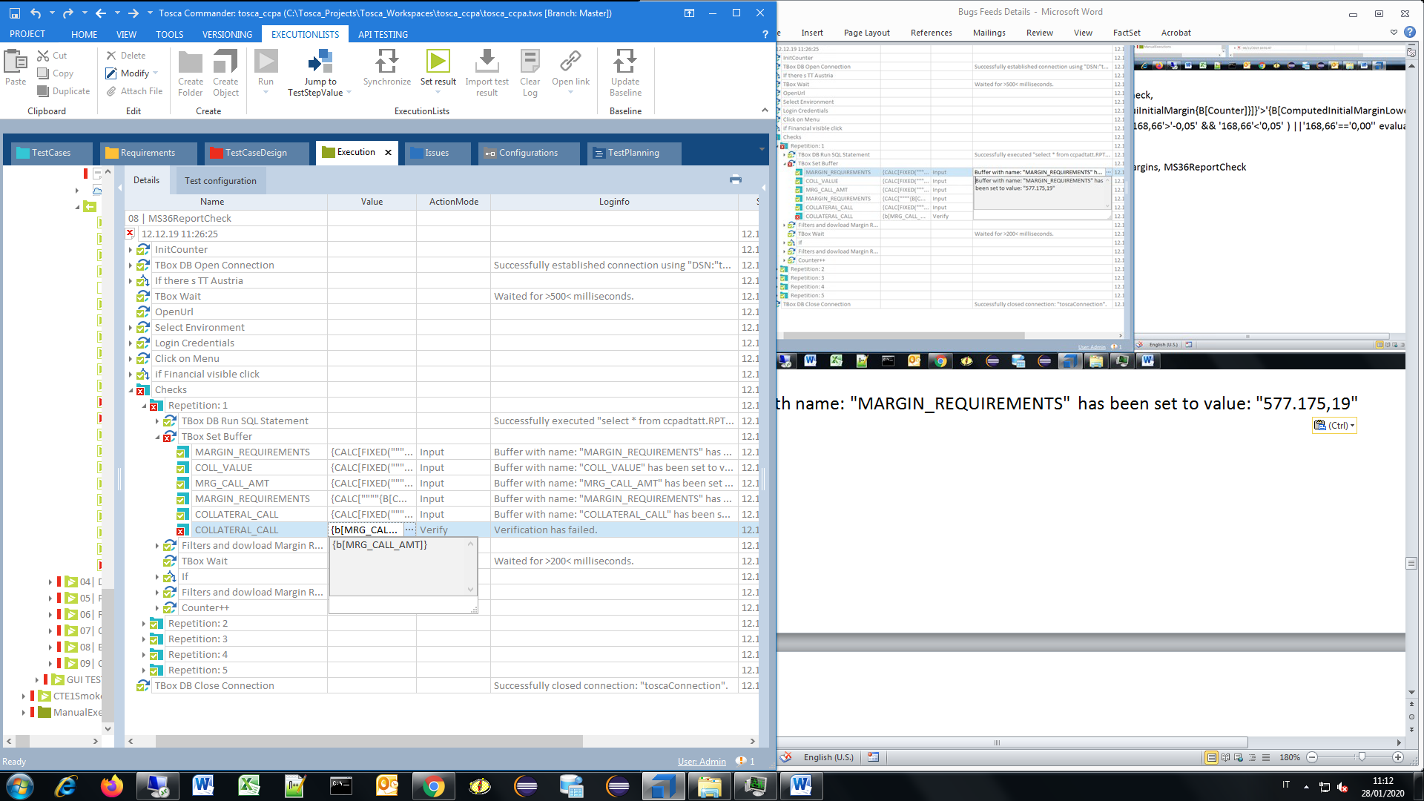

-COLLATERAL_CALL, Verification has …

10.A) Default Fund, averageMarginGuiCheck

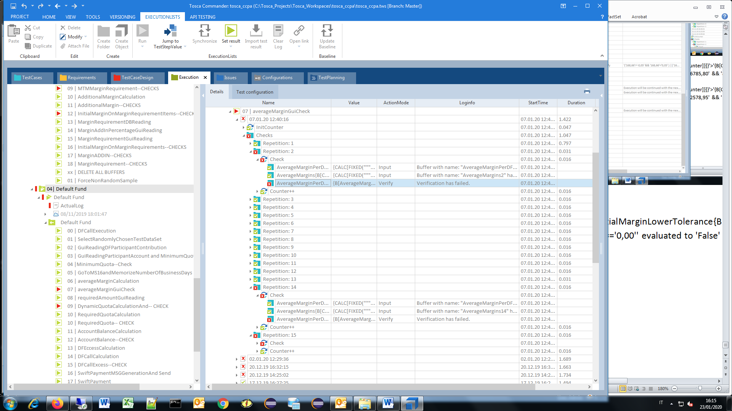

* AverageMargins{B[Counter]}]}, verification ….

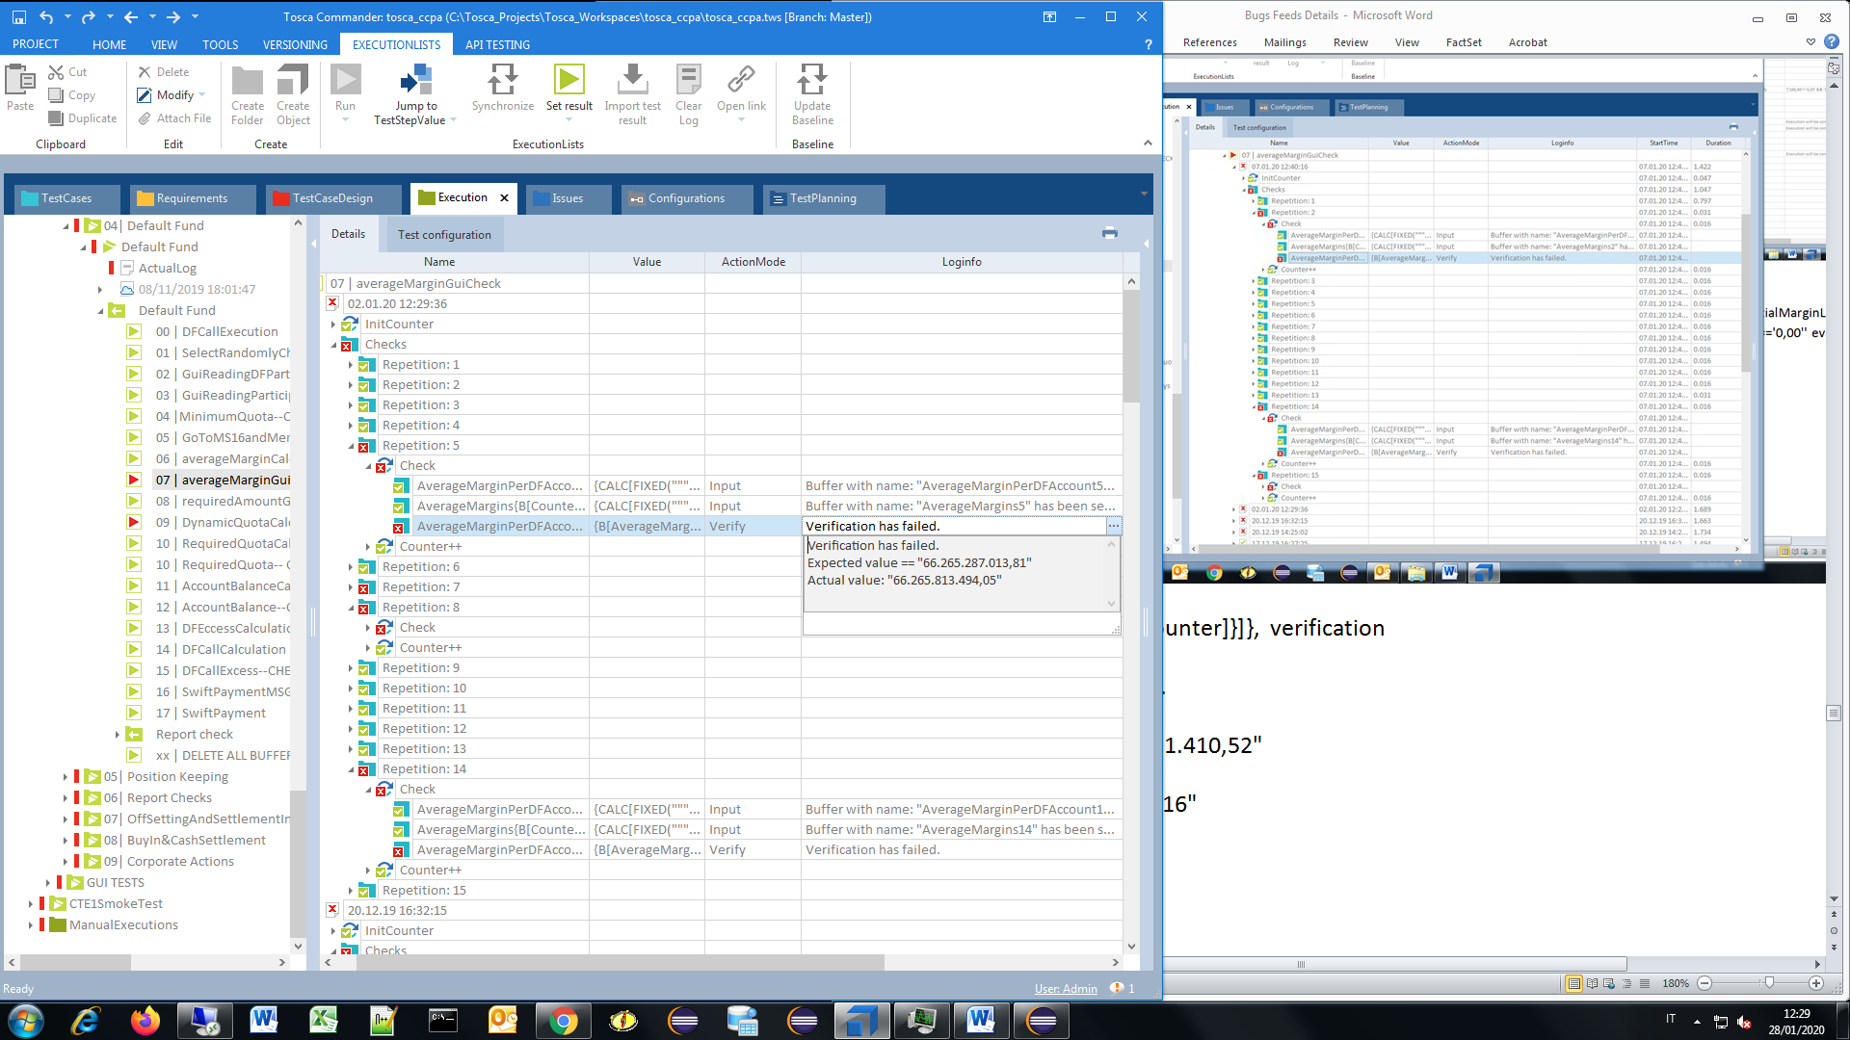

* Verification has .

Expected value == "66.265.287.013,81"

Actual value: "66.265.813.494,05",

* Verification has .

Expected value == "56.944.188,71"

Actual value: "56.944.188,72"

10.B) Default Fund, DynamicQuotaCalculationAnd—CHECKS

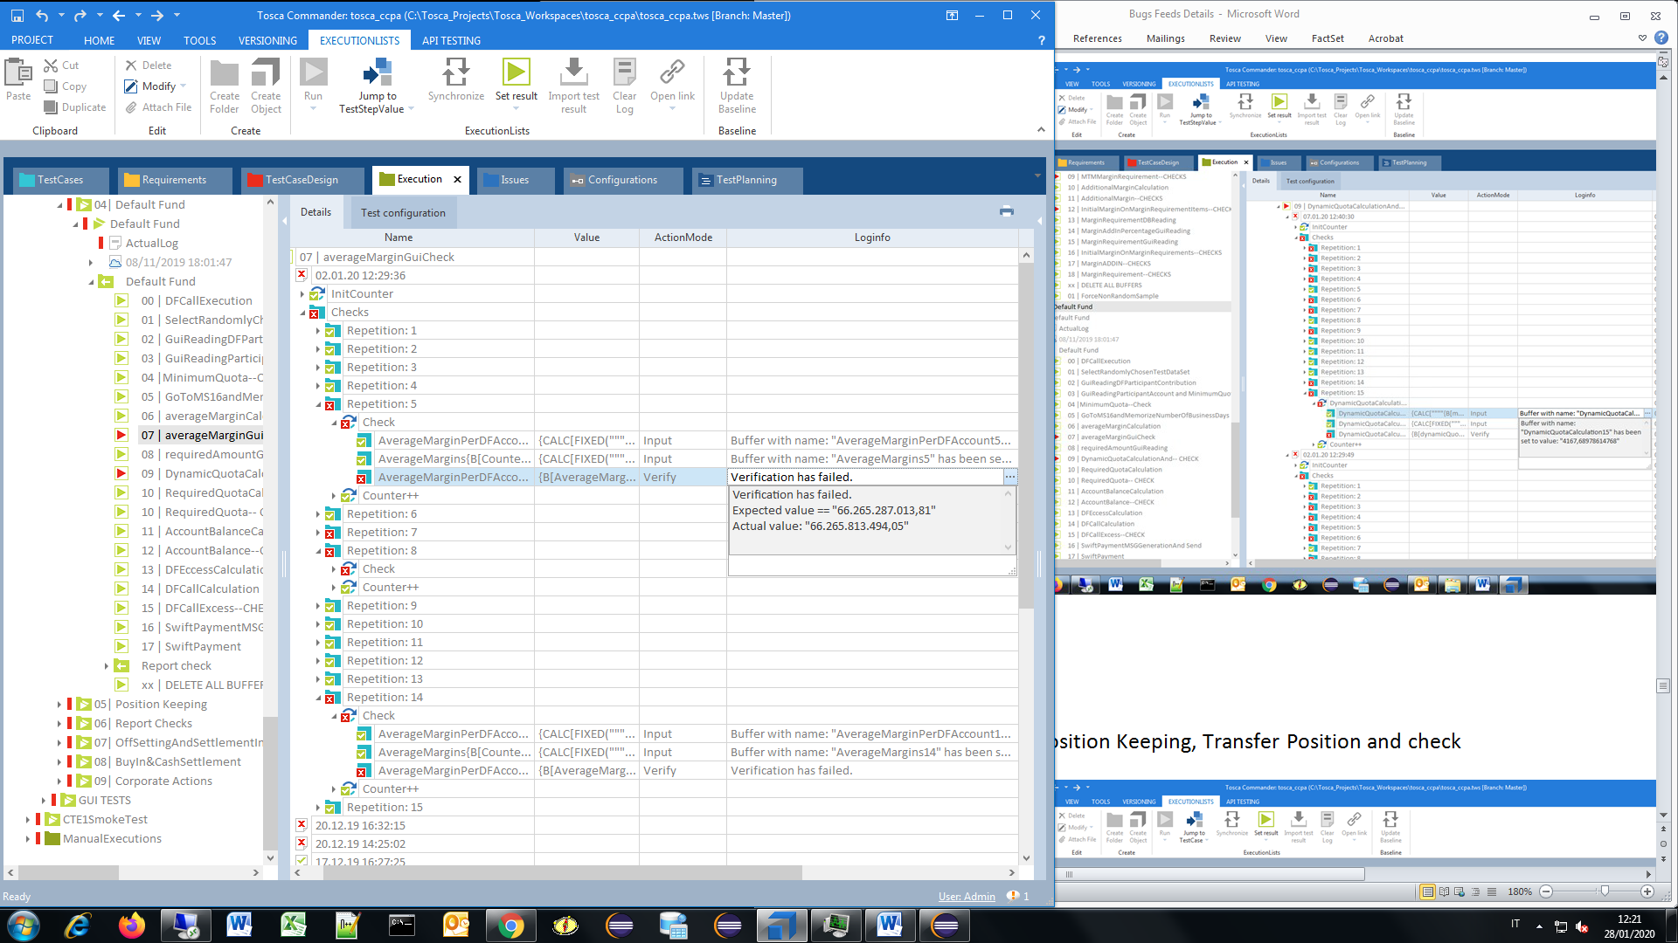

* Verification failed …

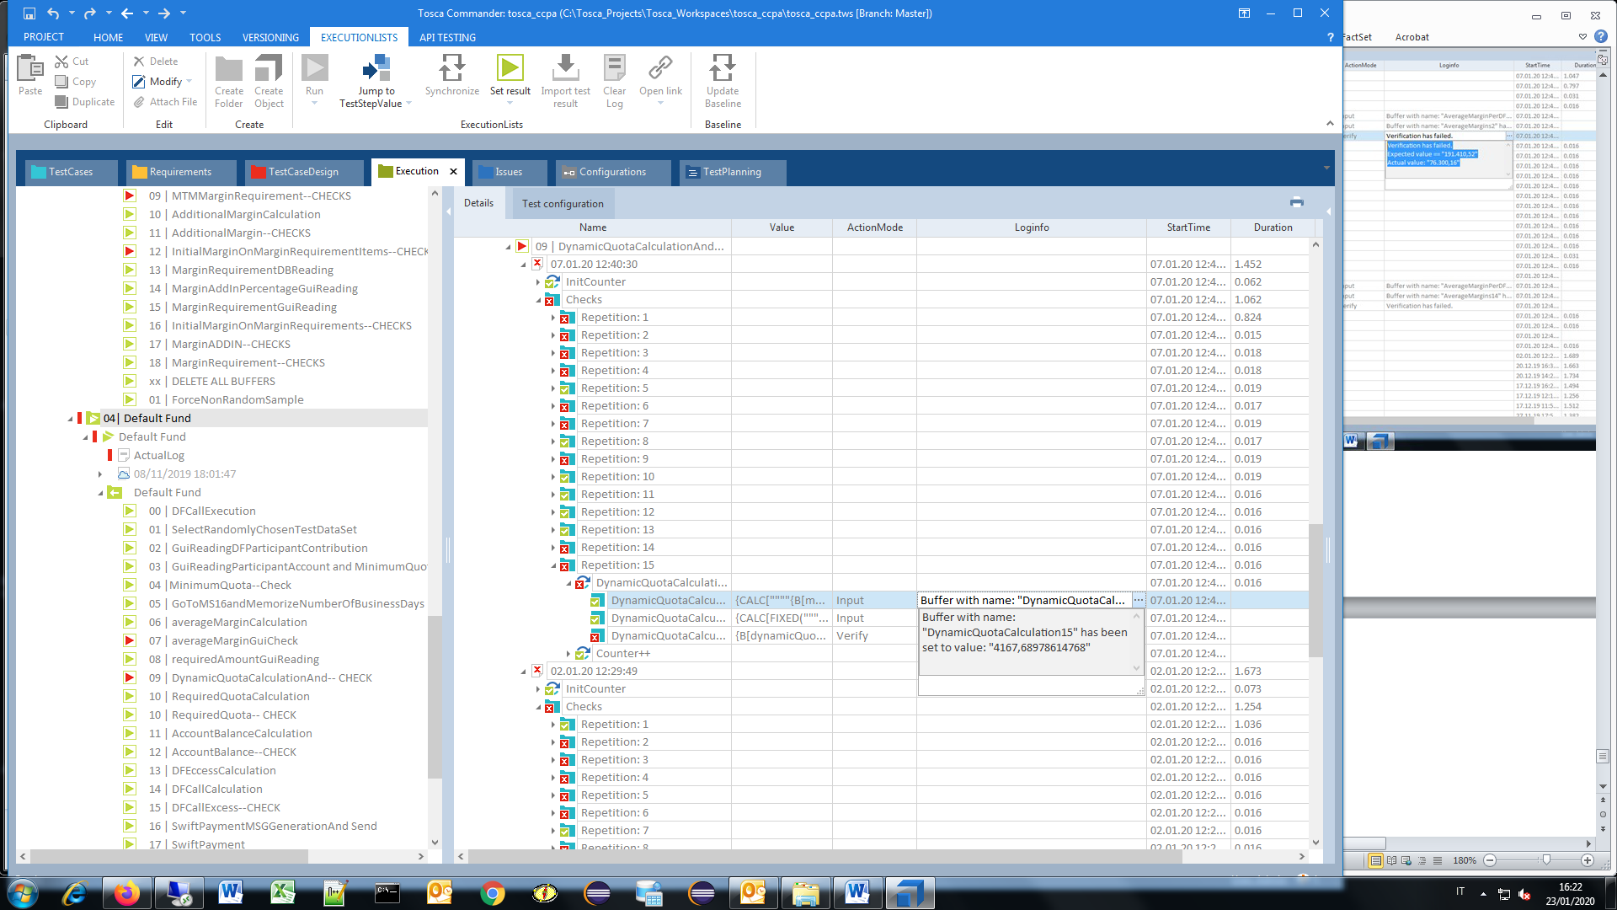

* repetitions

11.A) Position Keeping, Transfer Position and check

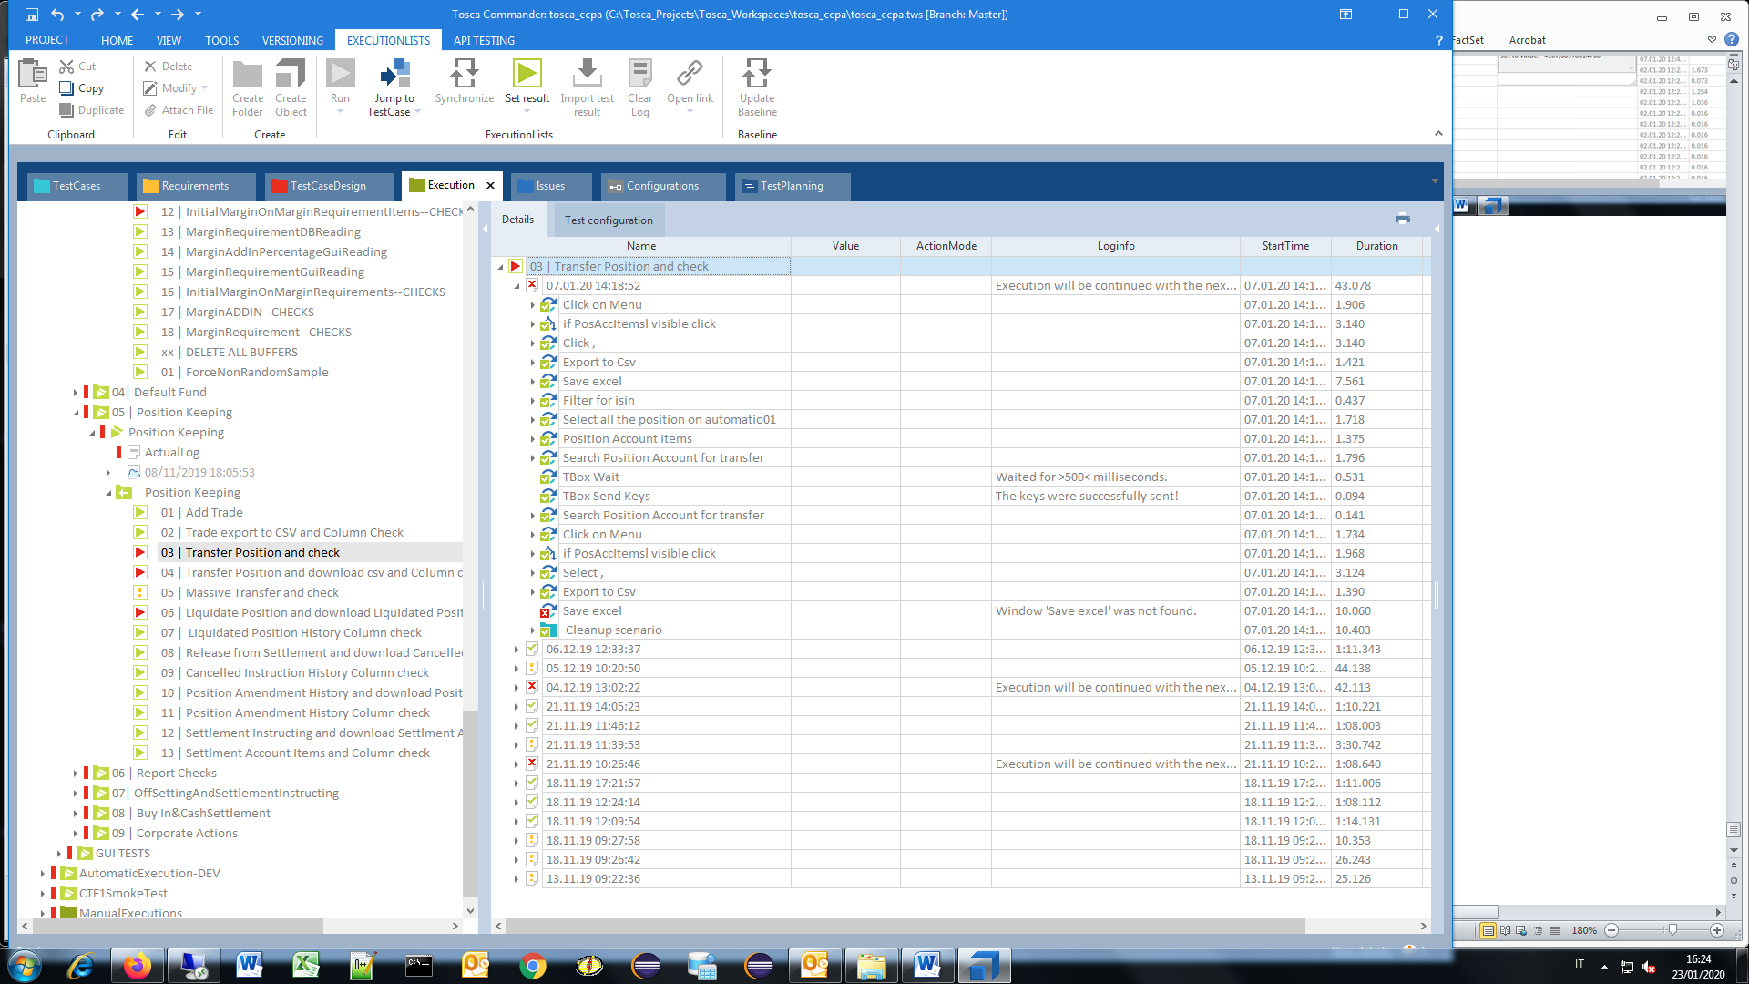

* Save excel, Window 'Save excel' was not found

11.B) Position Keeping, Liquidate Position and download Liquidated Position History

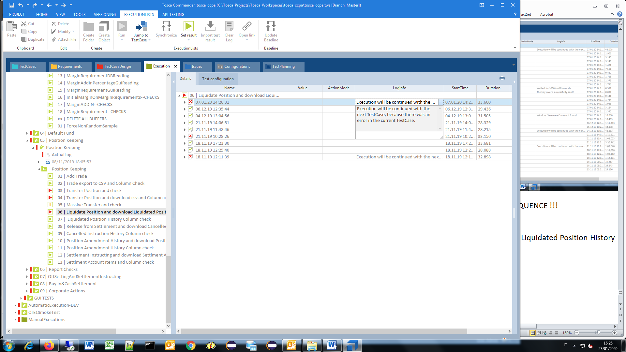

* Execution will be continued with the next TestCase, because there was an error ….

11.C) Position Keeping, Transfer Position and download csv and Column check

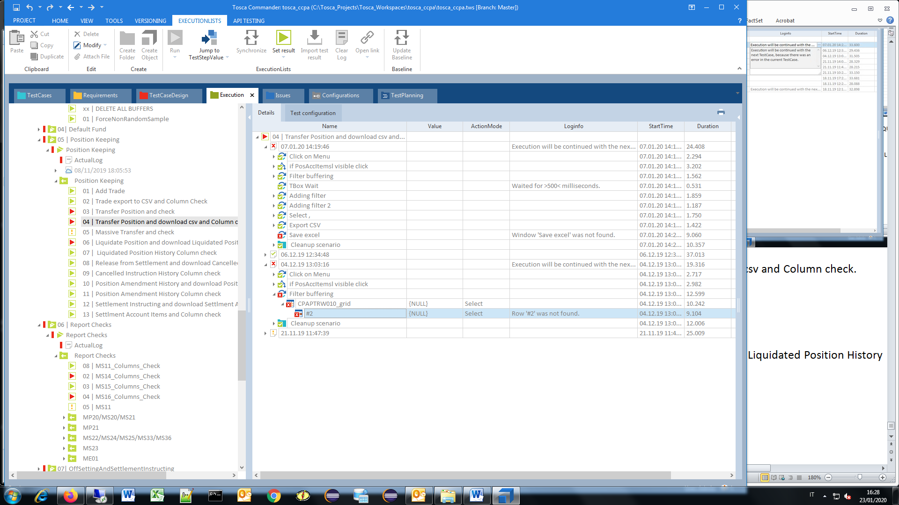

* CPAPTRW010_grid,

($2) Row '$2' was not found.

11.D) Position Keeping, Liquidate Position and download Liquidated Position History

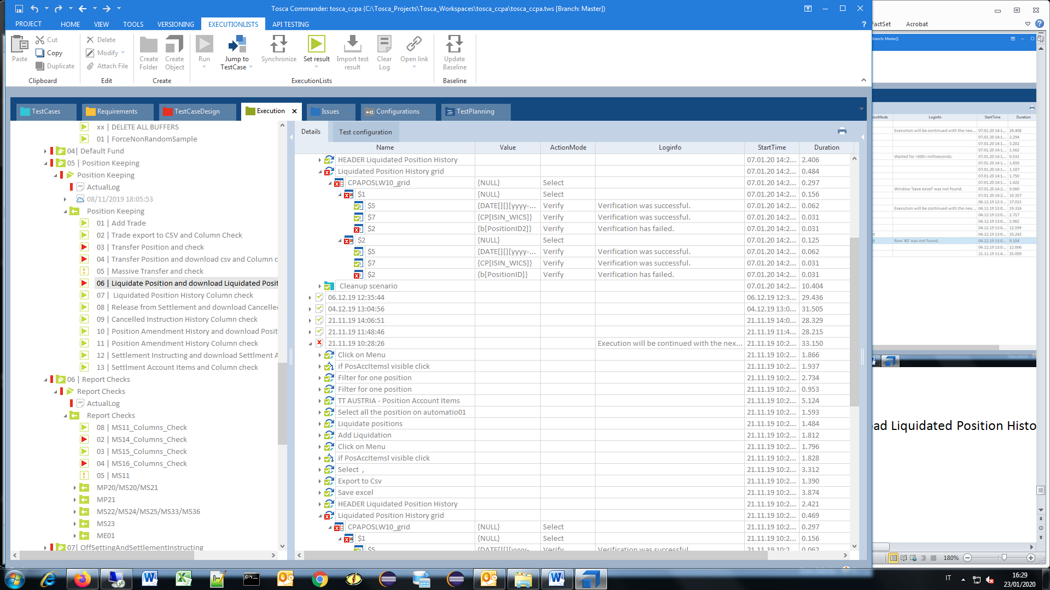

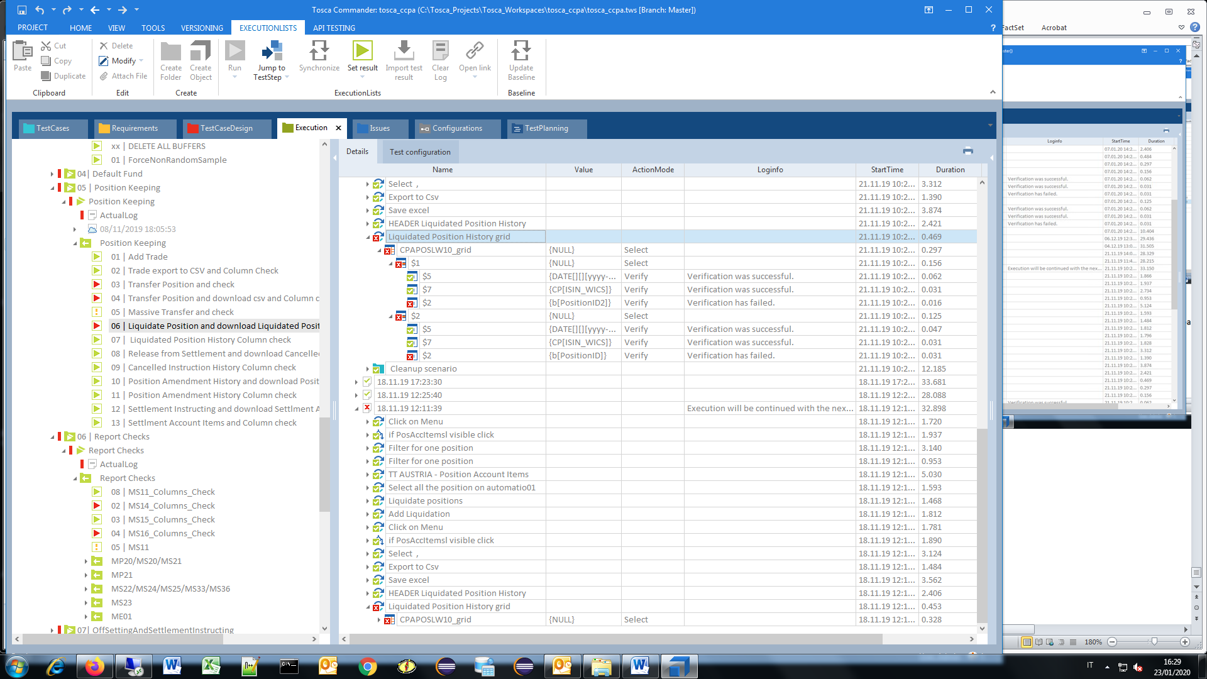

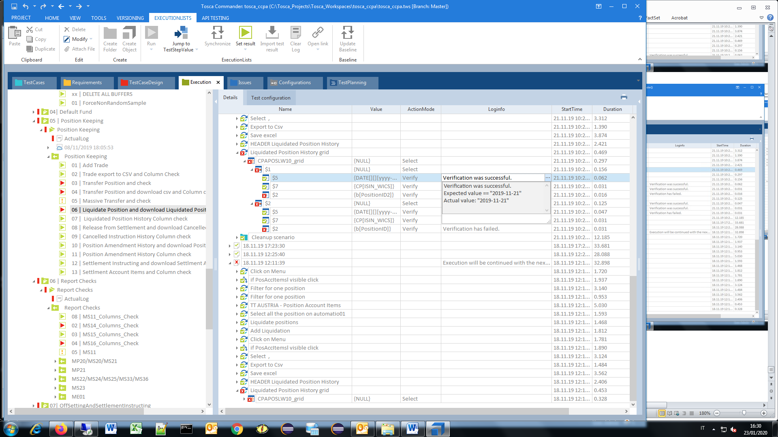

-CPAPOSLW10_grid

Verifications failed

12.A) ReportChecks, MS14_Columns_Check

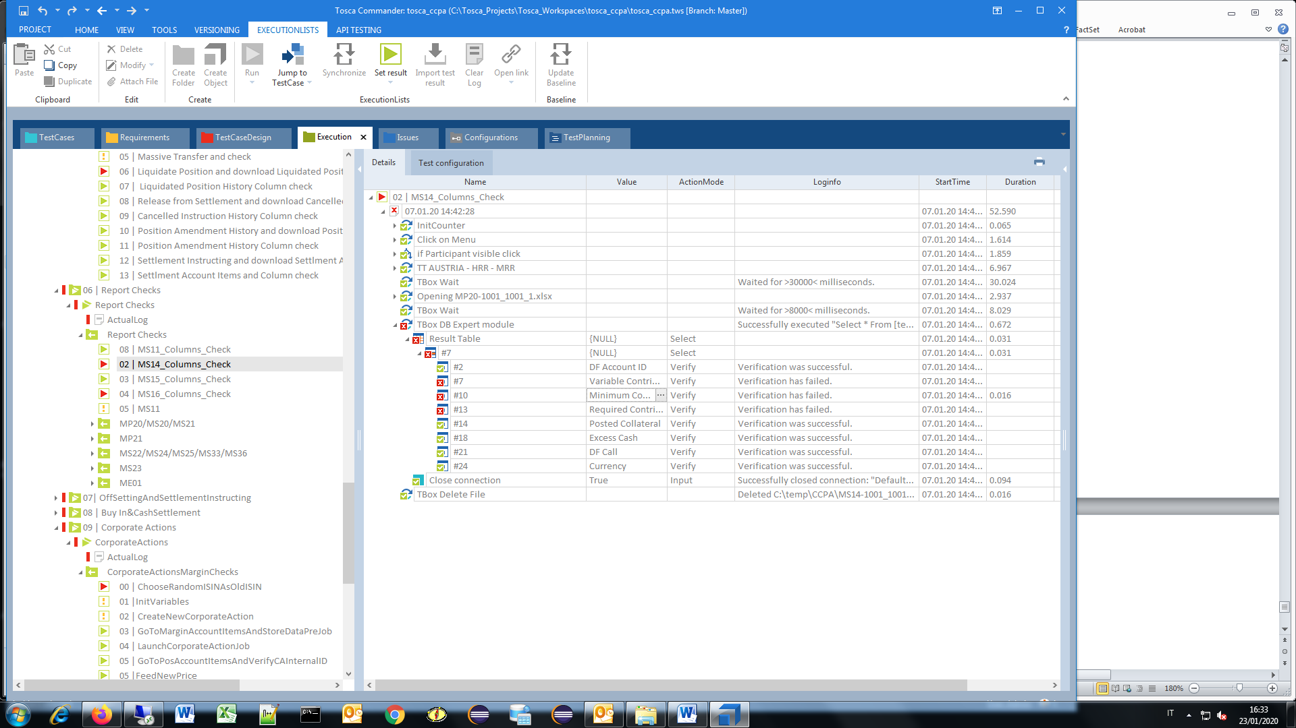

-Result Table (NULL)

#7 Variable Contribution,

#10 Minimum Contribution,

#13 Required Contribution

12.B) ReportChecks, MS16_Columns_Check

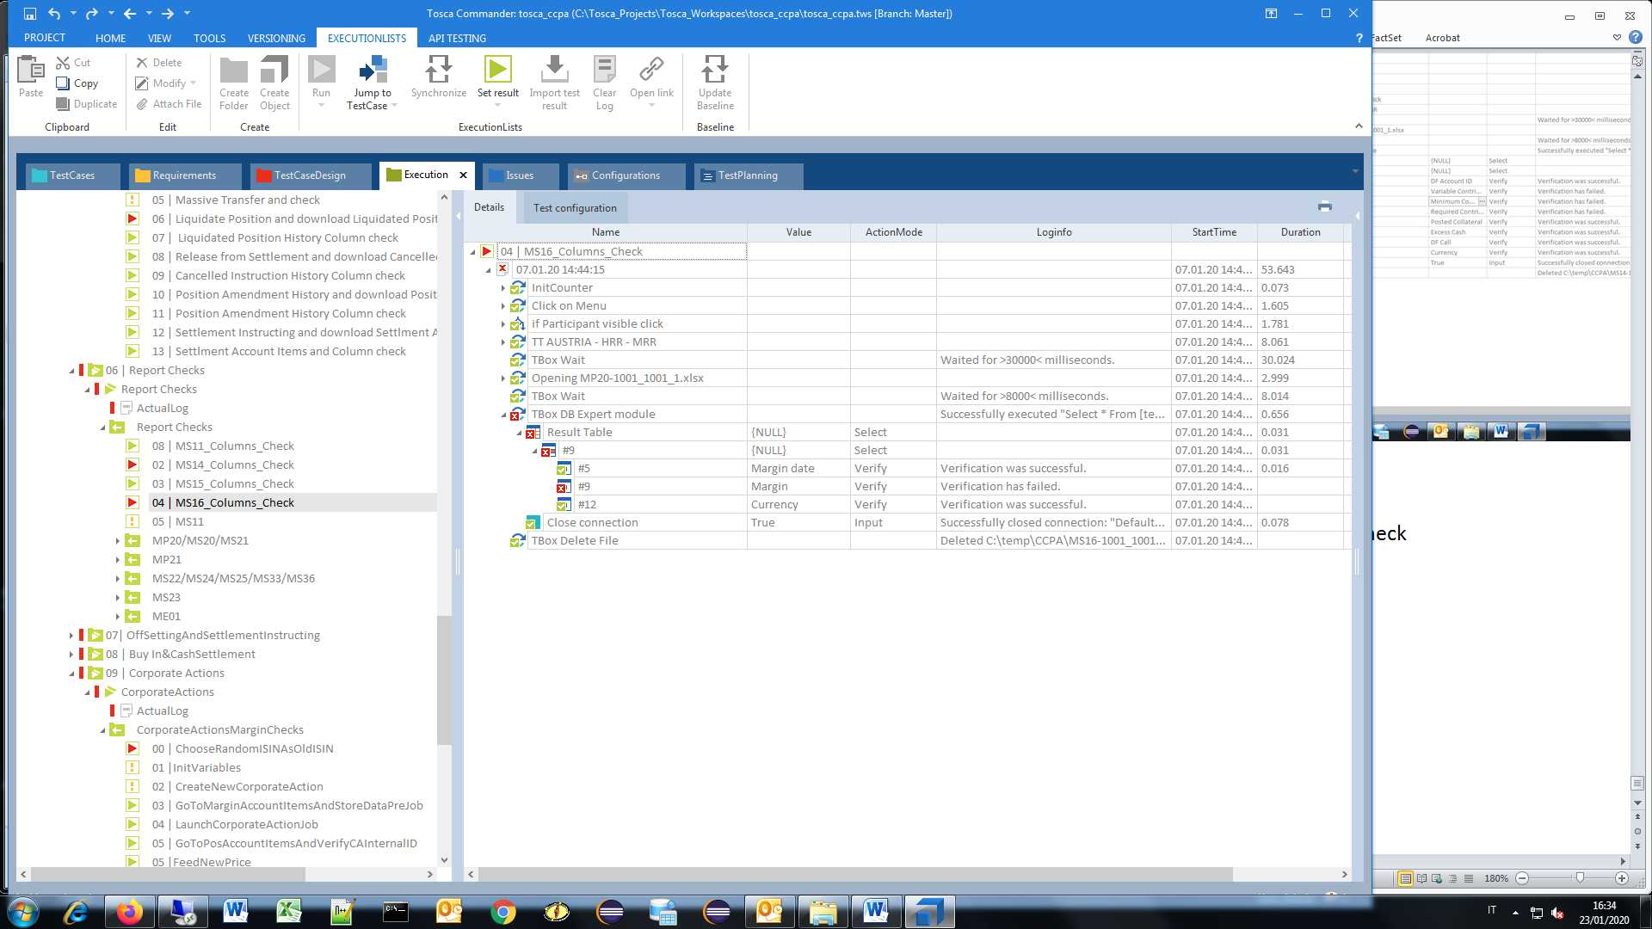

-Result Table (NULL)

#9 Variable Margins

13.A) CorporateActions, CorporateActionsMarginChecks

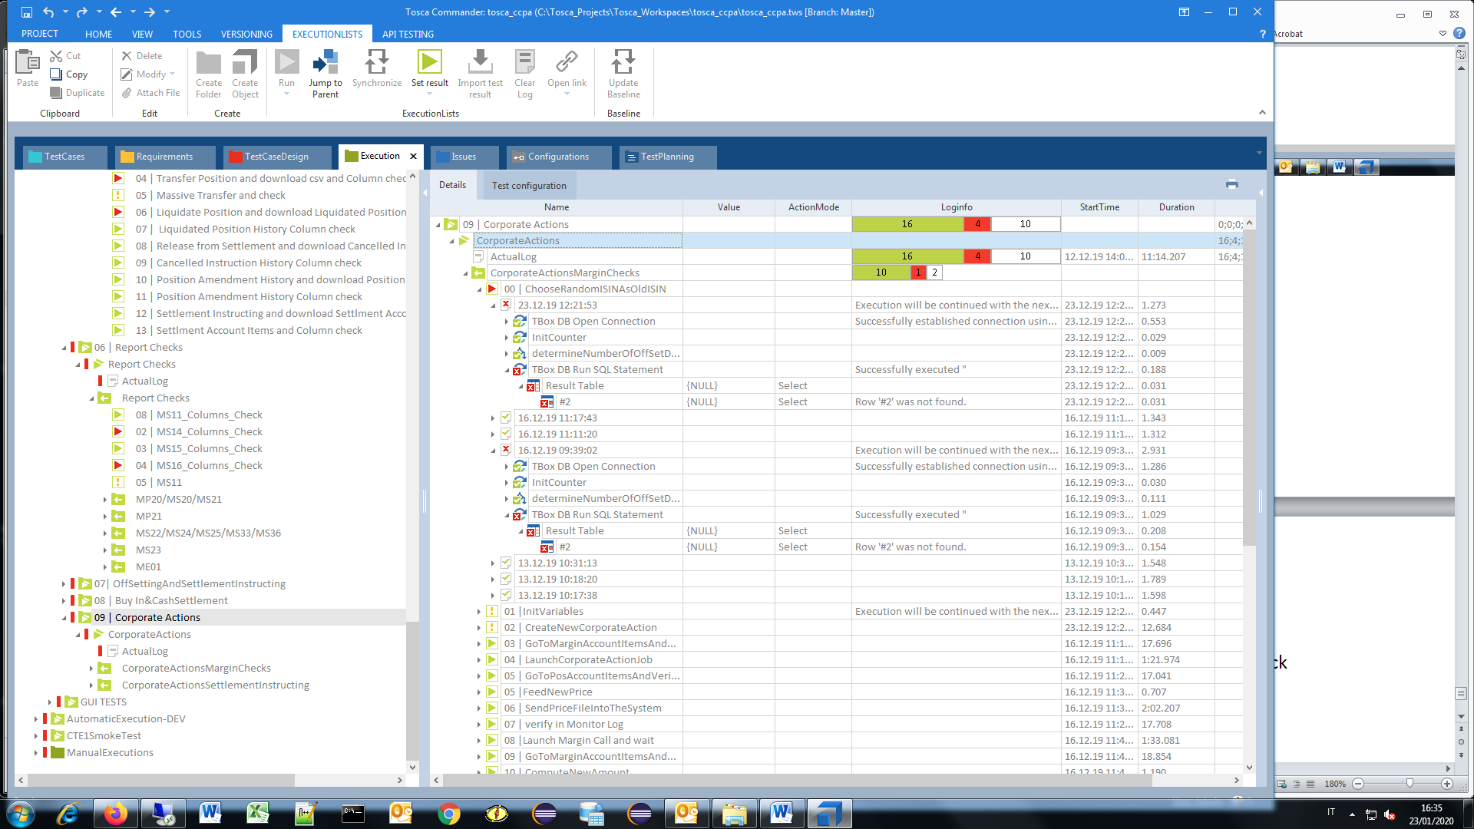

* ChooseRandomISINAsOldISIN

13.B) CorporateActions, CorporateActionsSettlementInstructing

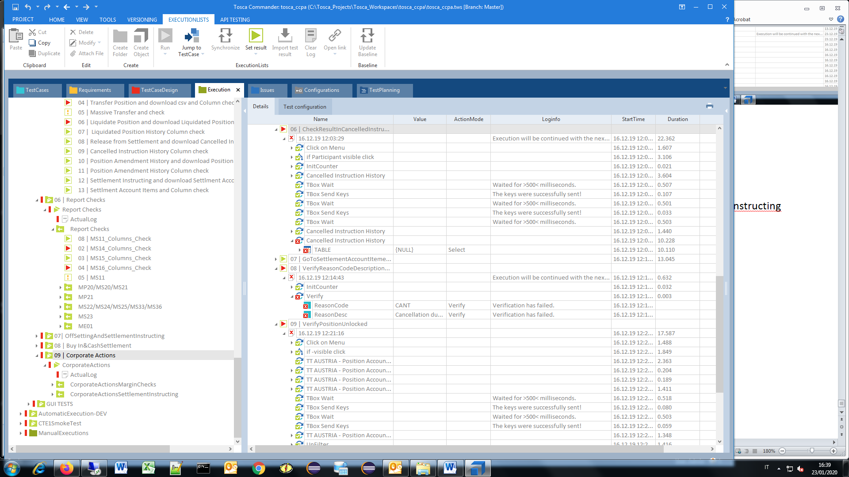

-CheckResultInCancelledInstructionHistory

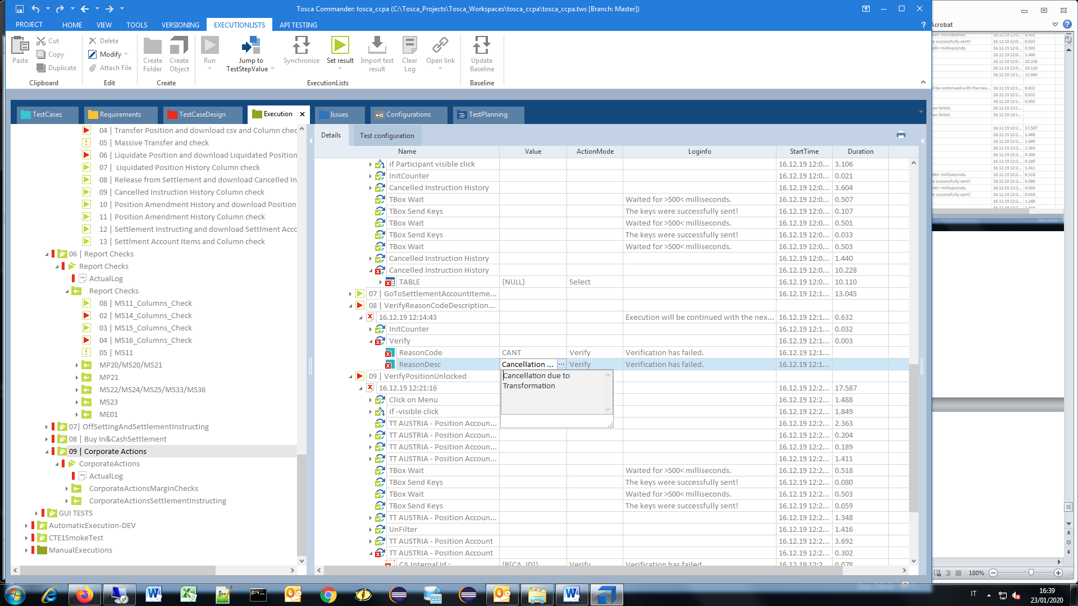

- VerifyReasonCodeDescriptionStatus

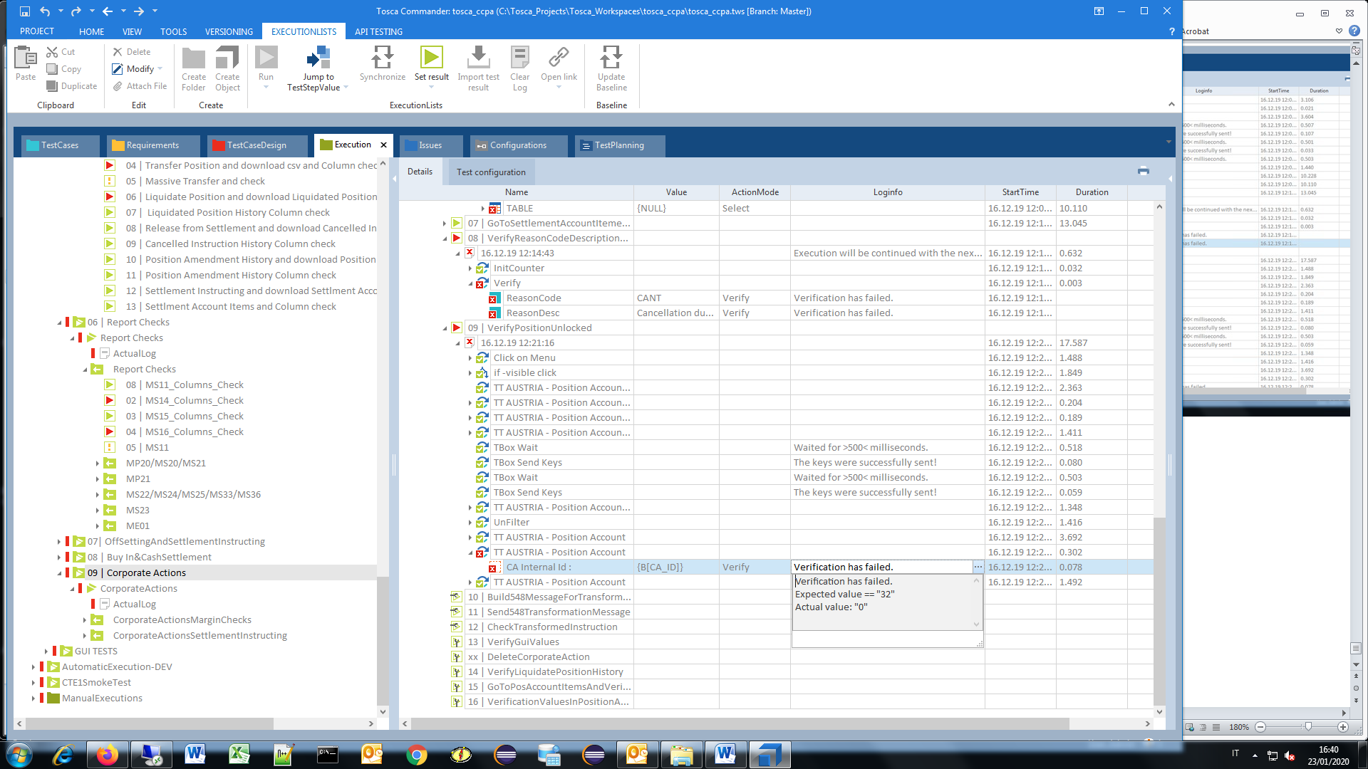

-VerifyPositionUnlocked